Jenkins Task-4
- Setup Jenkins CICD pipeline using freestyle job using Docker containers using below code.
Source Code: https://github.com/betawins/hiring-app.git
Stages:
Git Clone
SonarQube Integration
Maven Compilation
Nexus Artifactory
Slack Notification
Deploy On tomcat
- Install Java
Amazon Linux 2023:
sudo dnf install java-17-amazon-corretto -y
java -version
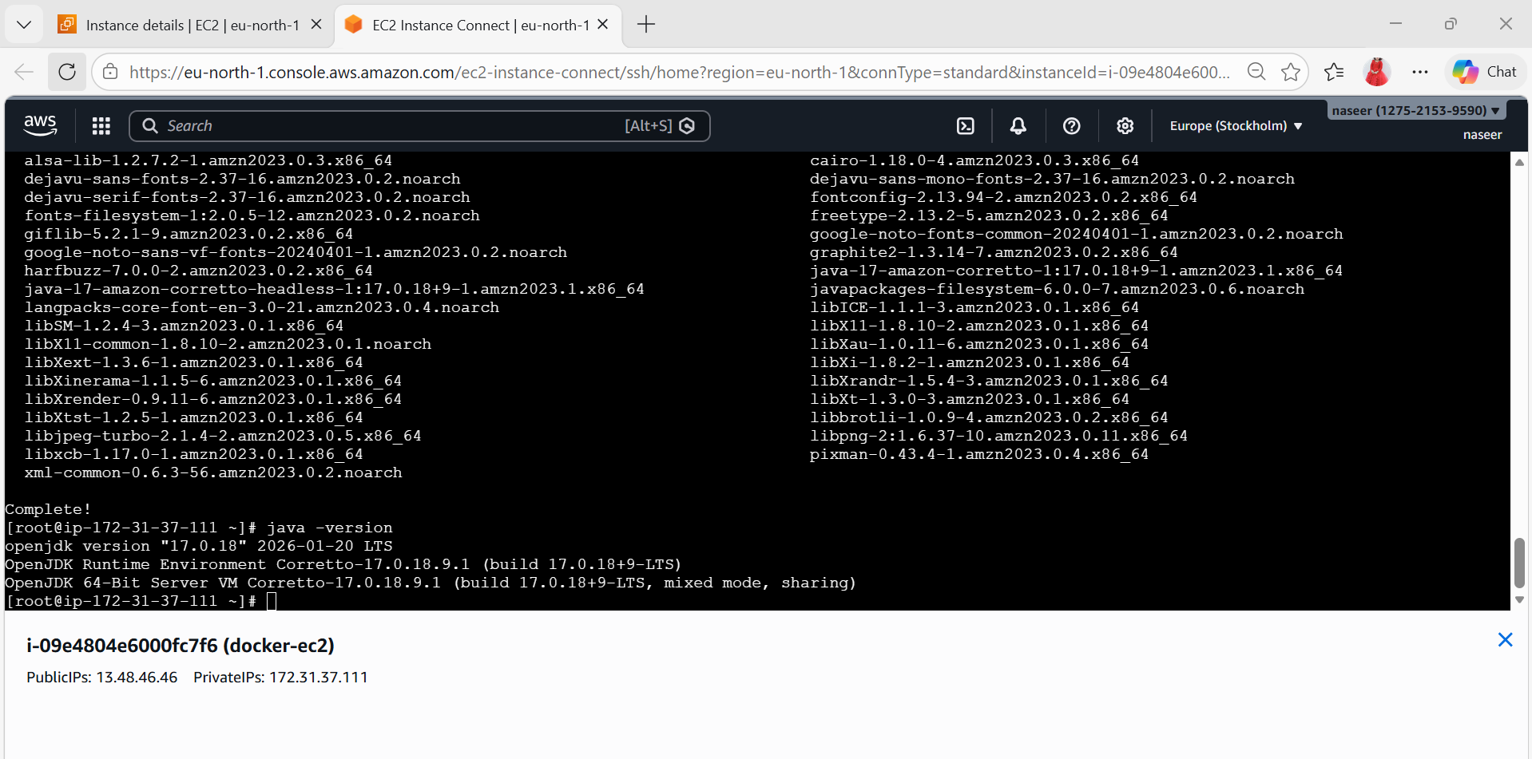

- Install Jenkins
sudo wget -O /etc/yum.repos.d/jenkins.repo \
https://pkg.jenkins.io/redhat-stable/jenkins.repo
sudo rpm --import https://pkg.jenkins.io/redhat-stable/jenkins.io.key
sudo yum install jenkins -y
sudo systemctl start jenkins
sudo systemctl enable Jenkins
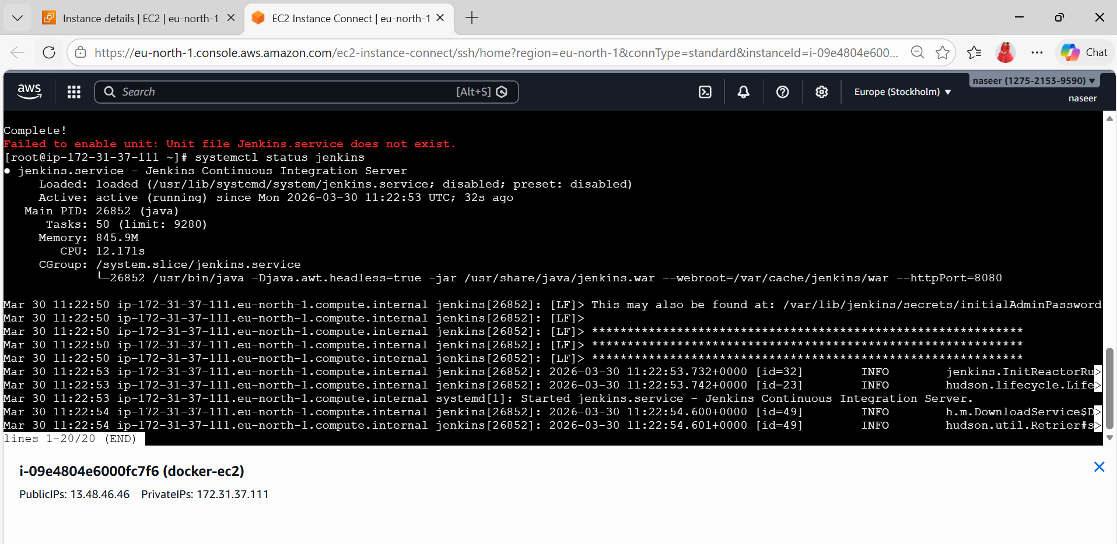

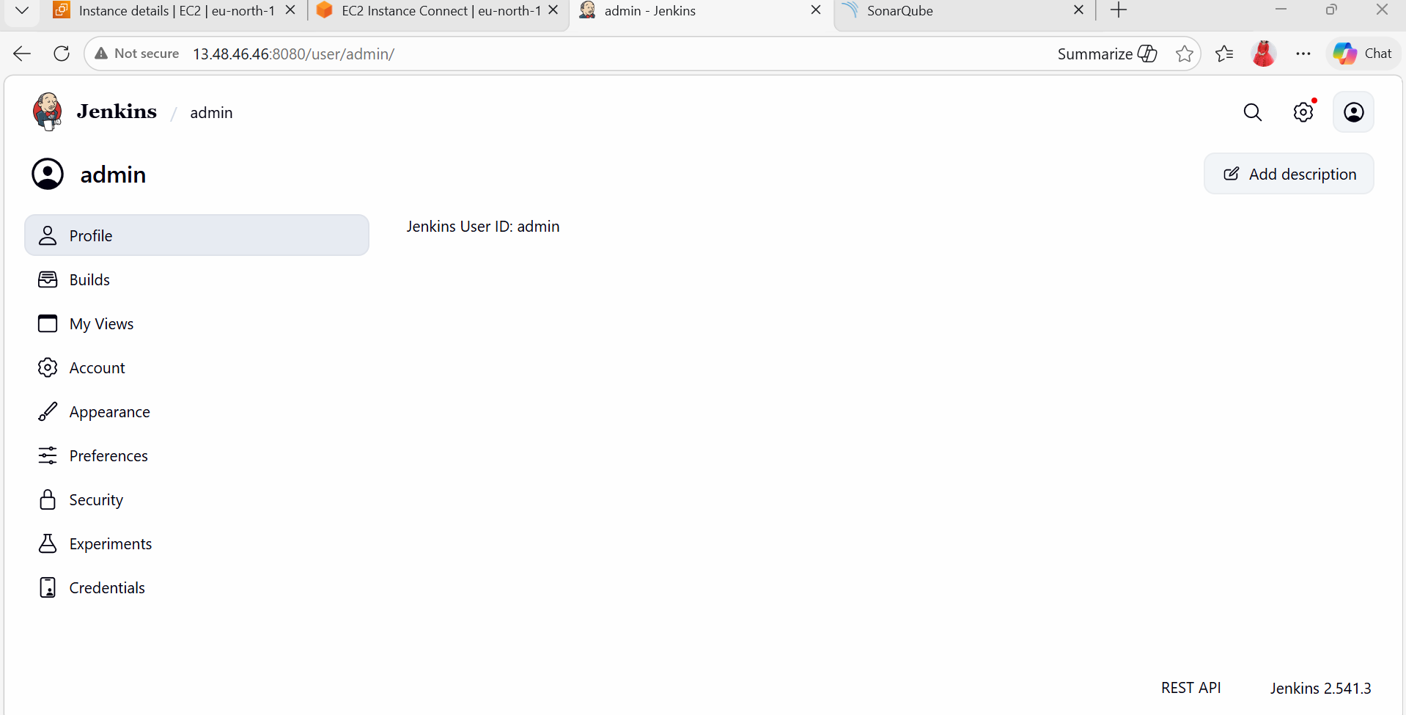
- Install Docker
sudo yum install docker -y
sudo systemctl start docker
sudo systemctl enable docker

Add permissions:
sudo usermod -aG docker ec2-user
sudo usermod -aG docker jenkins

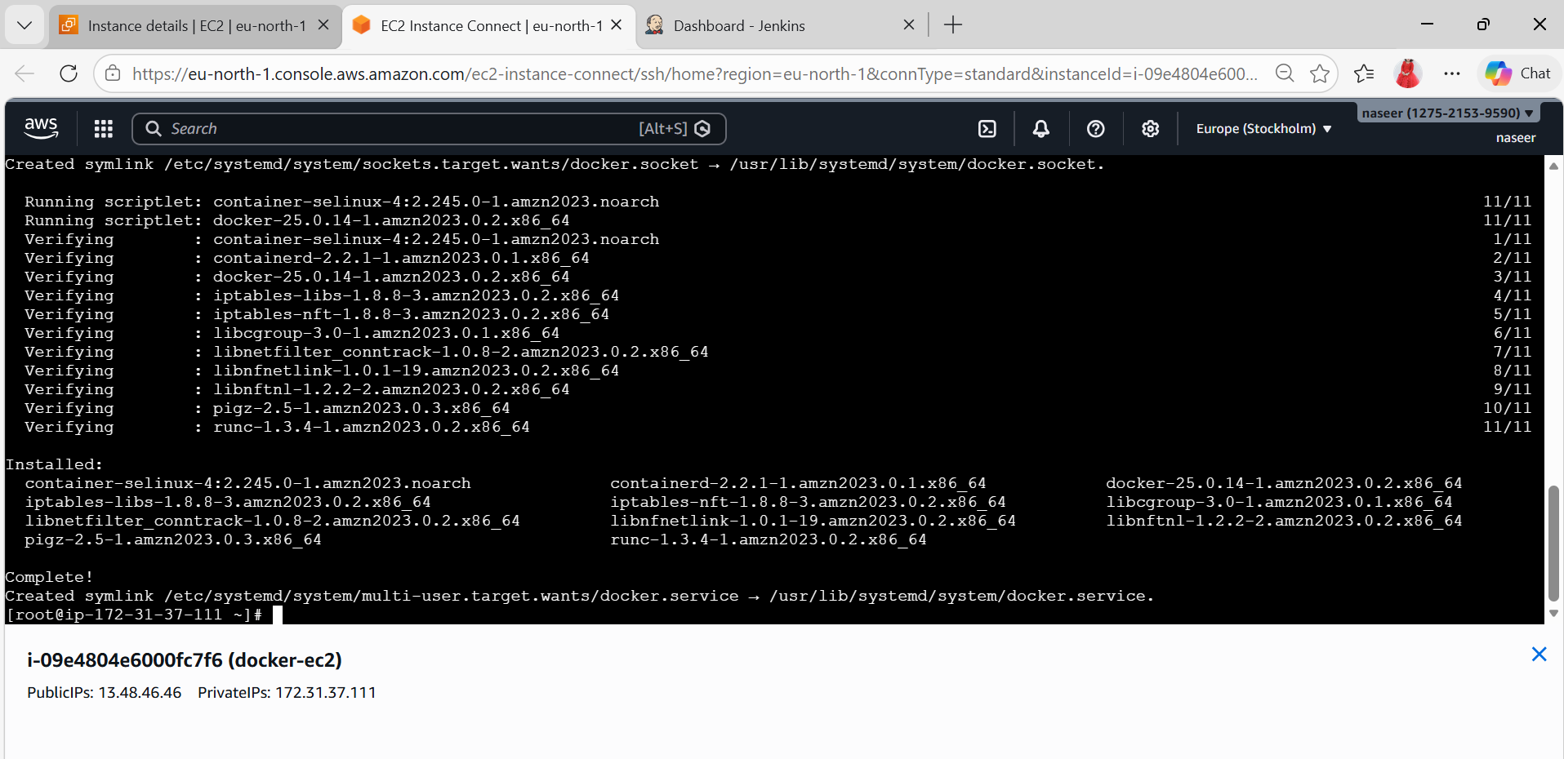
- Install Maven
sudo yum install maven -y
Verify:
mvn -version
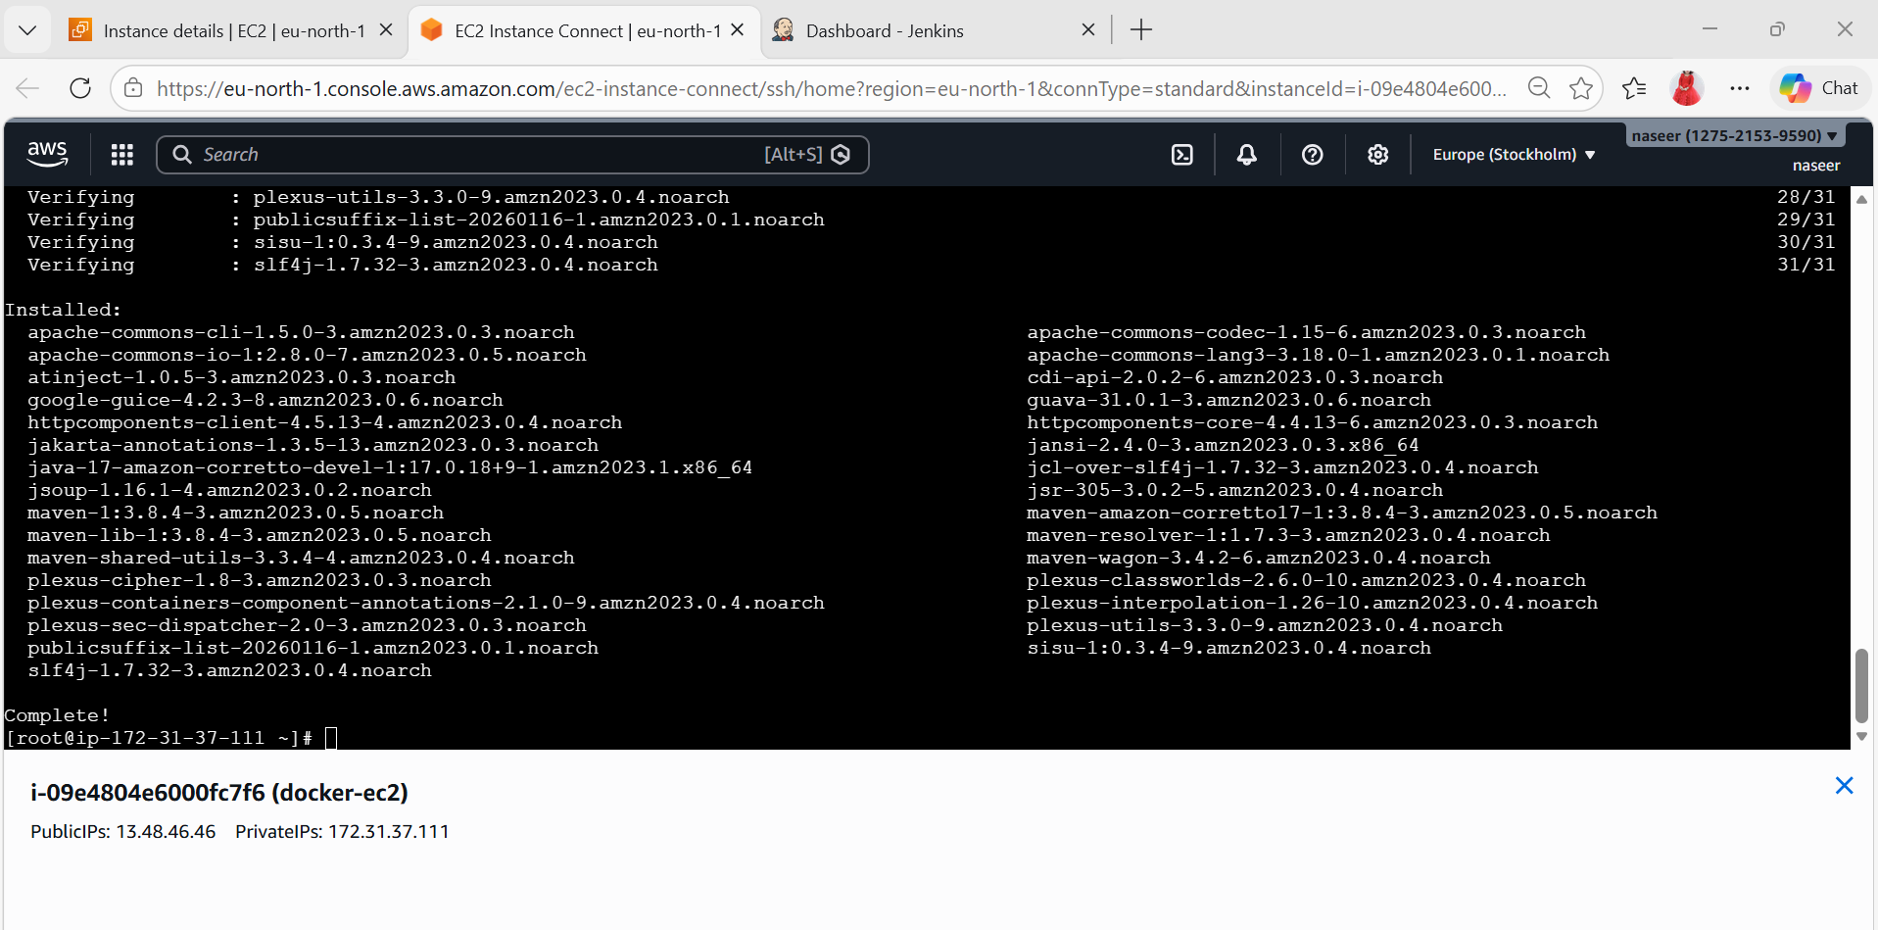
- Install SonarQube (Docker)
docker run -d --name sonar \
-p 9000:9000 sonarqube:lts
URL:
http://13.48.46.46:9000
Login: admin / admin
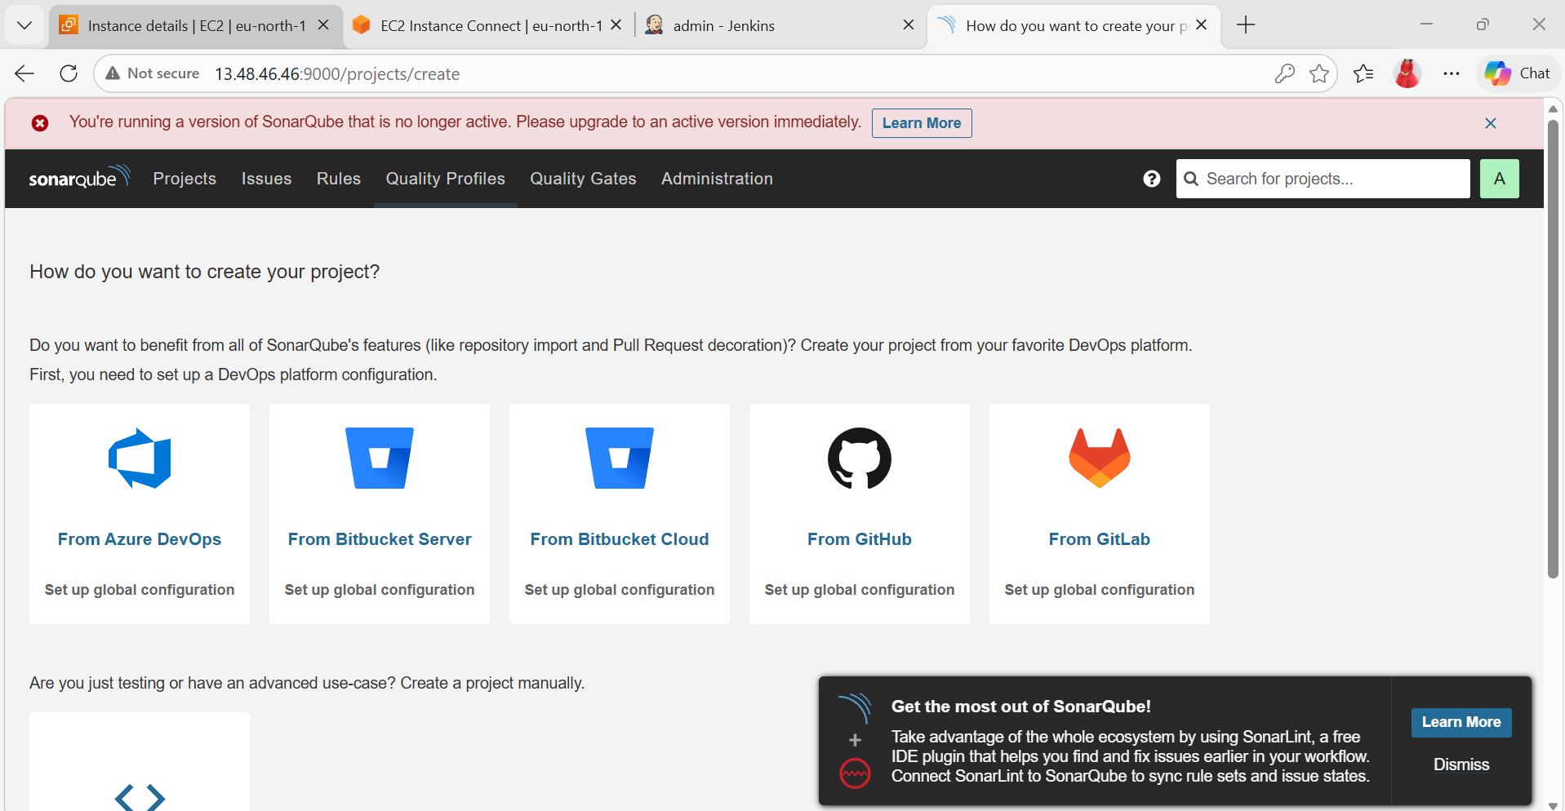
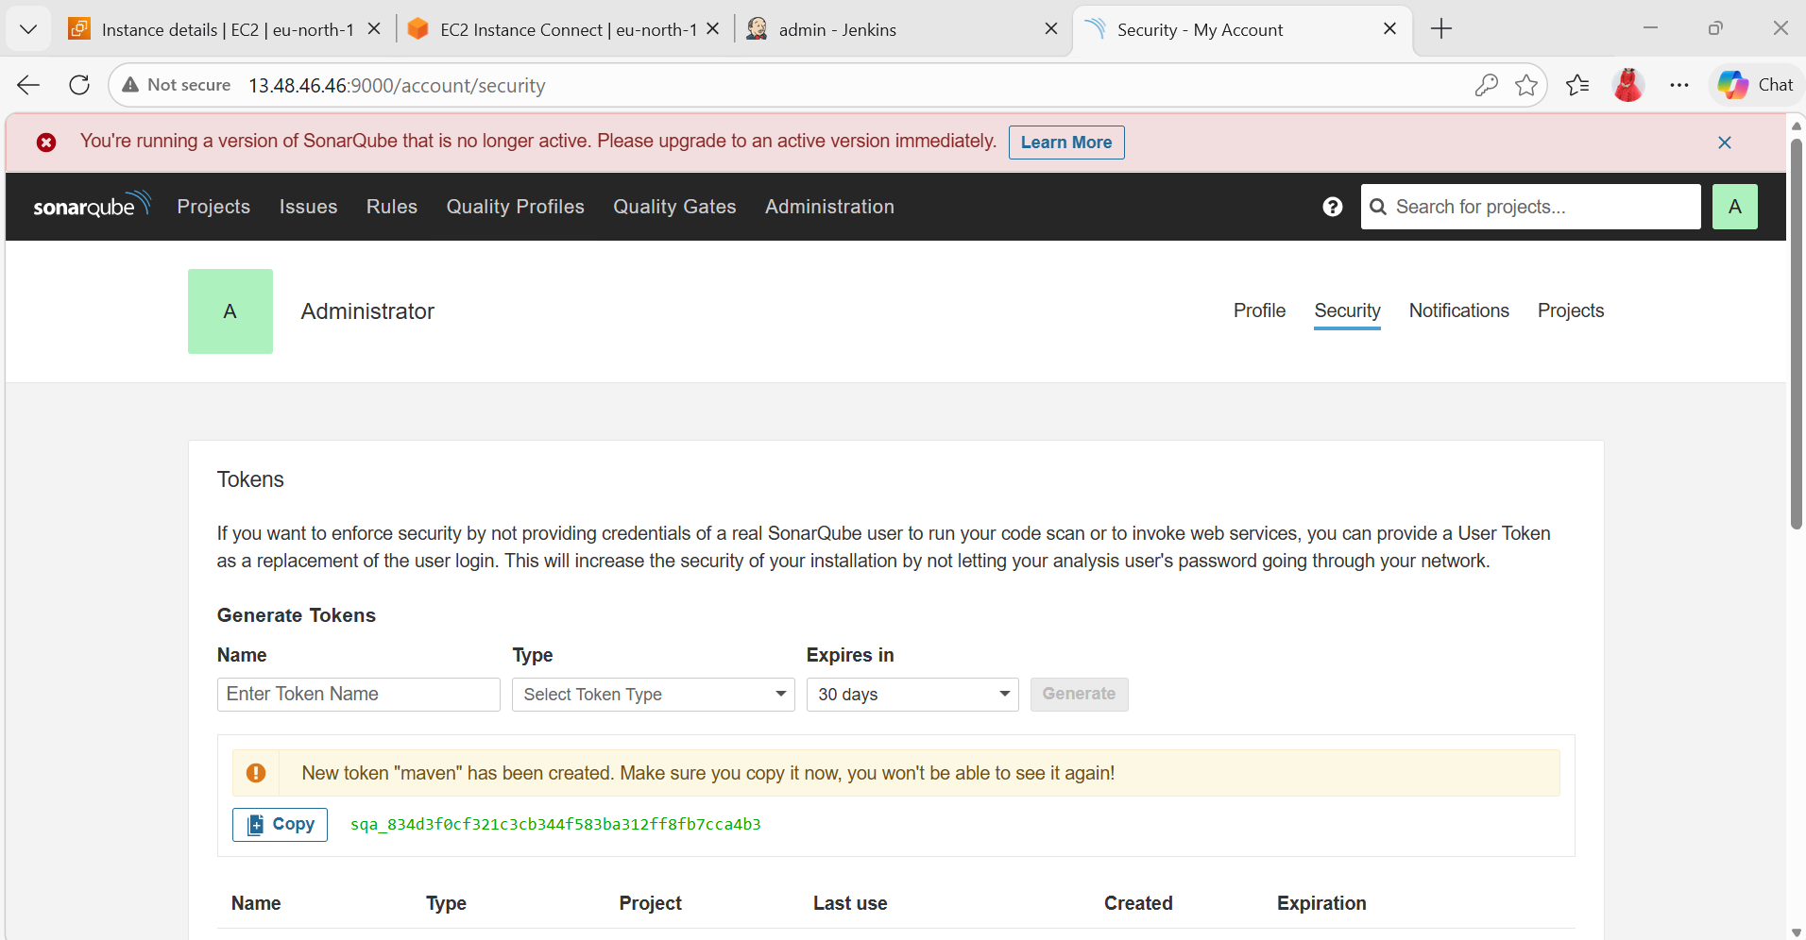

- Install Nexus (Docker)
docker run -d --name nexus \
-p 8081:8081 sonatype/nexus3

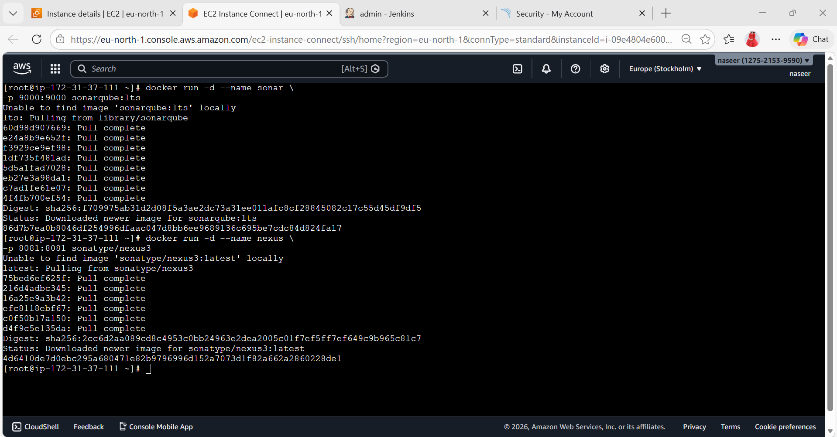
URL:
http://13.48.46.46:8081
Password:
docker exec -it nexus cat /nexus-data/admin.password
Username: admin
Password: 21a80926-d12d-4ce6-8d00-48db7f45690d
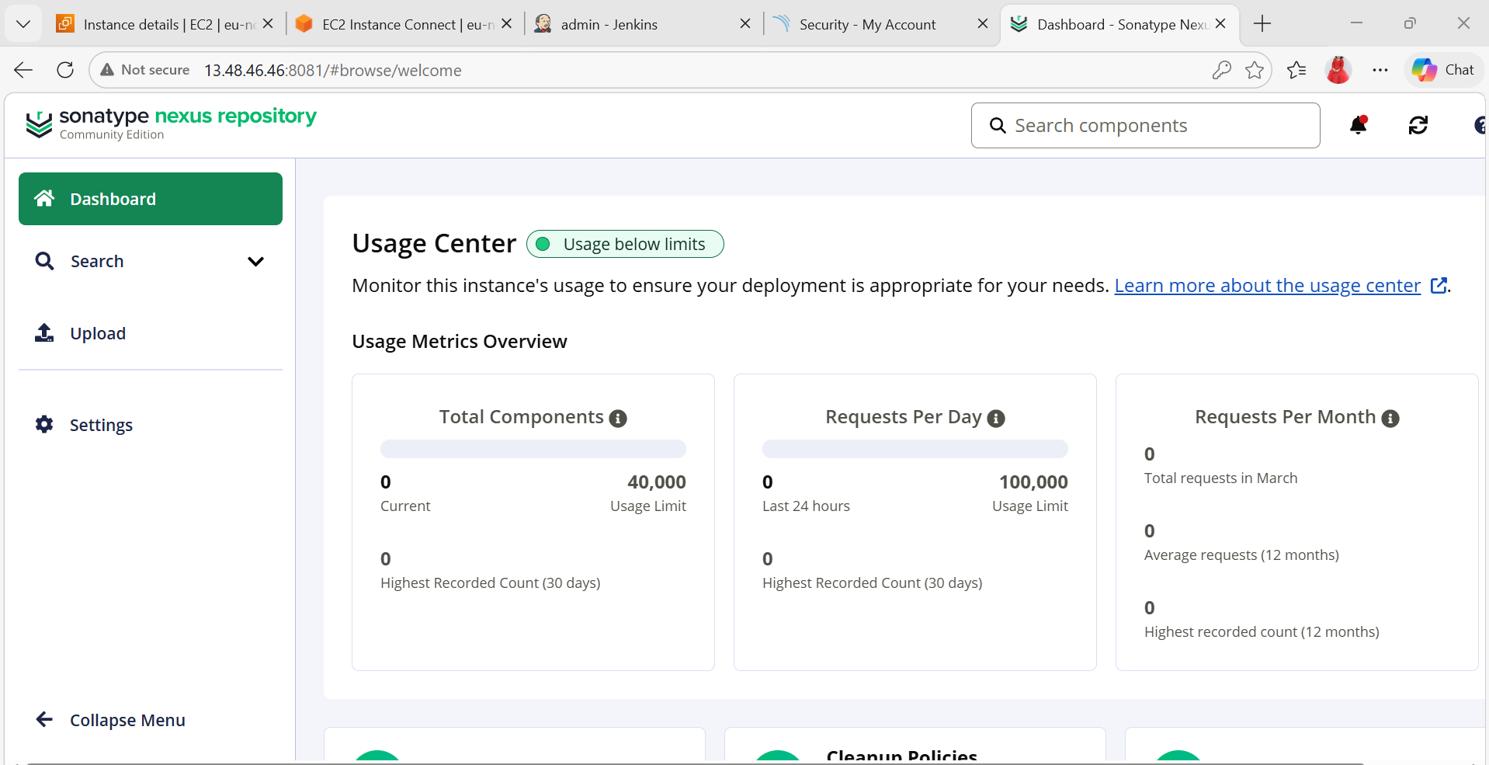
- Install Tomcat (Docker)
docker run -d --name tomcat \
-p 8082:8080 tomcat

http://13.48.46.46:8082
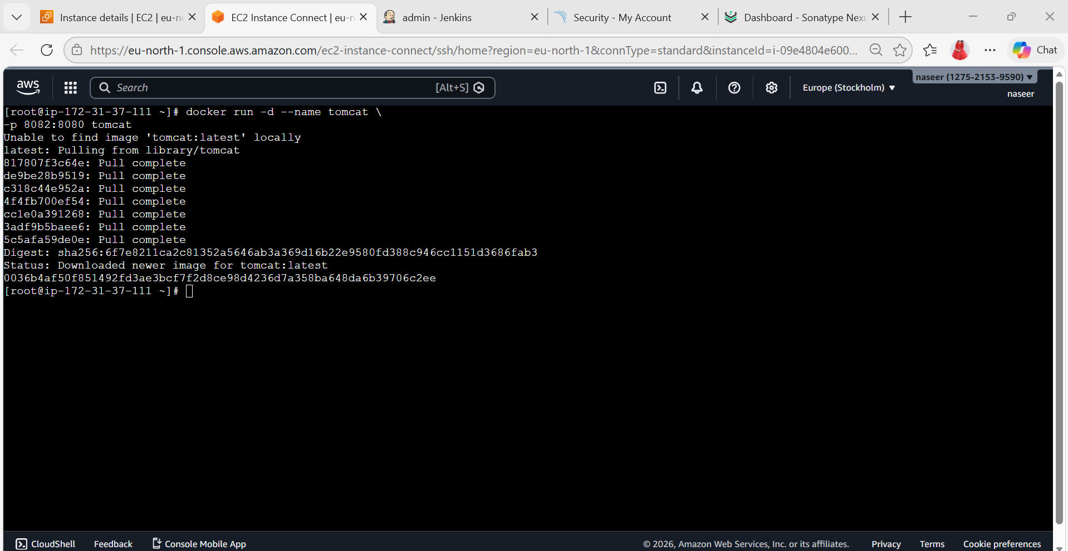
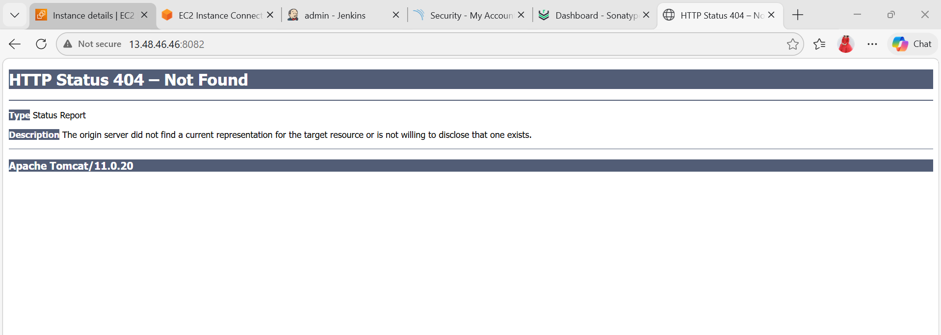
Install:
- Git
sudo yum install git -y
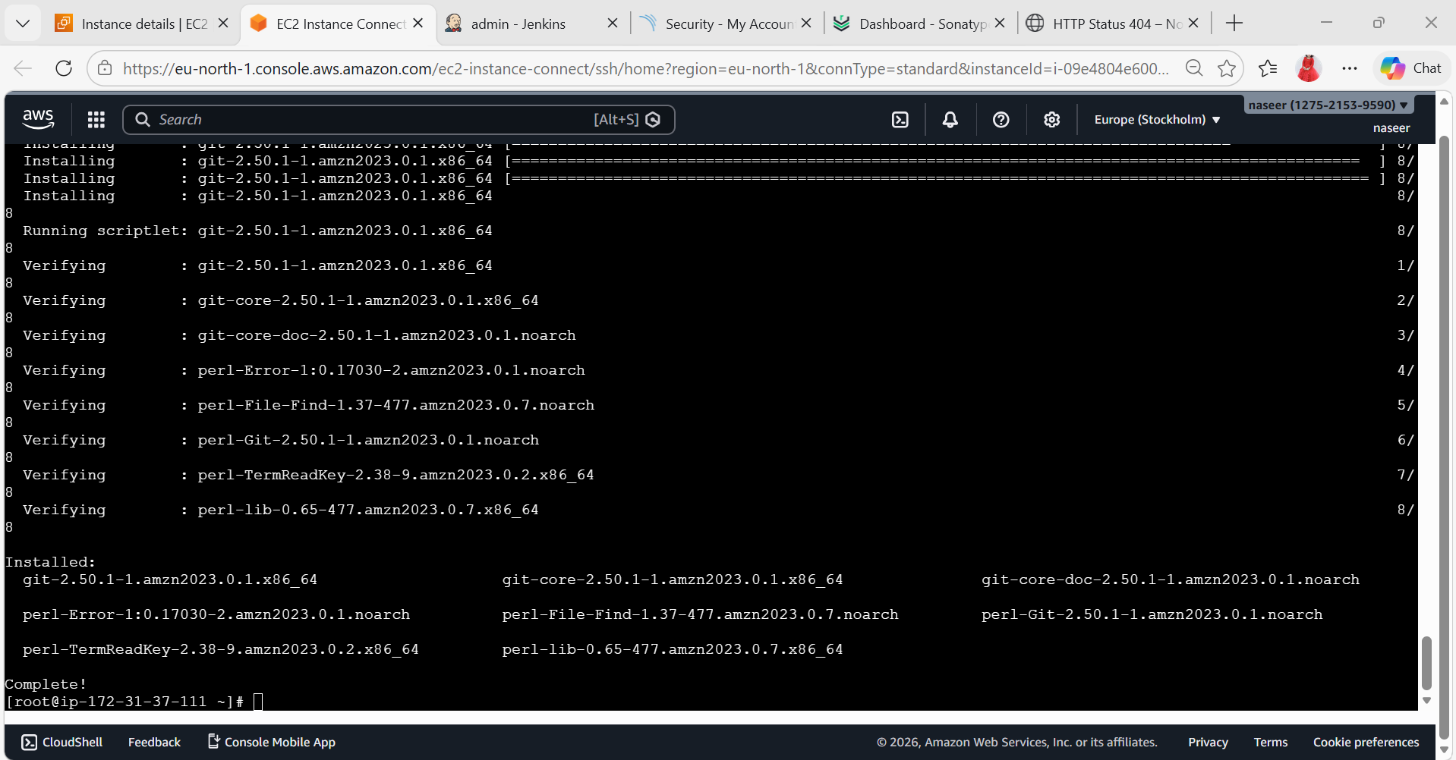

Install plugins:
- Maven Integration
- SonarQube Scanner
- Nexus Artifact Uploader
- Slack Notification
- Pipeline

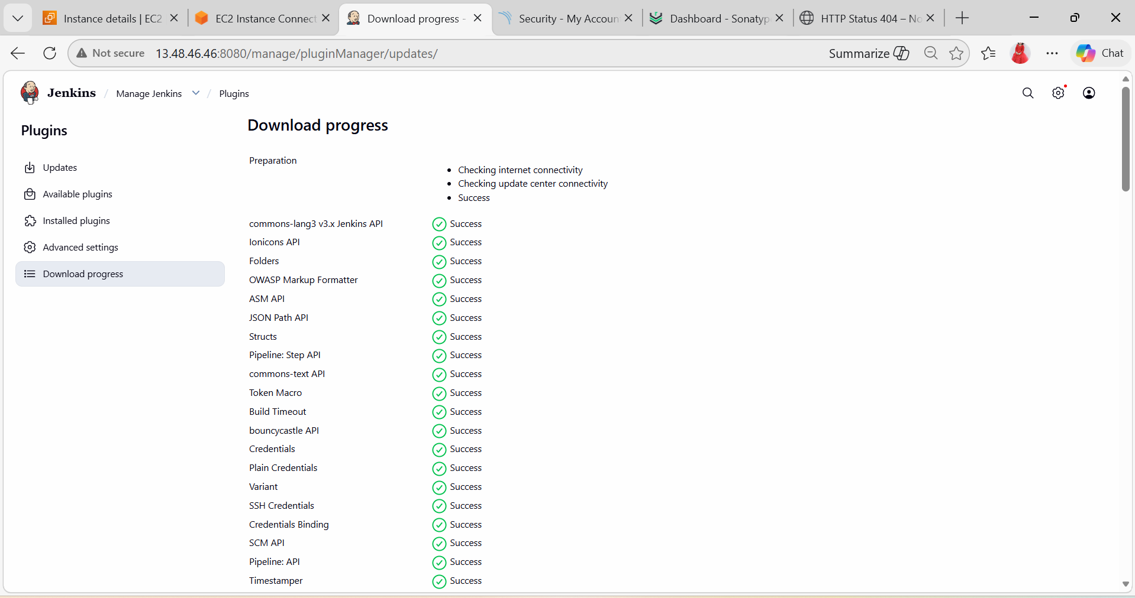

Go to:
Manage Jenkins → Global Tool Configuration
Configure Git
- Name: Git
- Path: /usr/bin/git
Configure Maven
- Click Add Maven
- Name: Maven
- Tick: Install automatically
Configure SonarQube Scanner
- Click Add SonarQube Scanner
- Name: SonarScanner
- Tick: Install automatically
- Configure SonarQube Server
Go to: Manage Jenkins → Configure System
Find: SonarQube Servers
Add:
- Name: SonarQube
- Server URL: http://<SonarQube-IP>:9000
- Add Token (from SonarQube)
- Configure Slack
Go to: Manage Jenkins → Configure System
Find: Slack
Add:
- Workspace
- Channel: #jenkins
- Token Credential (Slack Webhook or Bot Token)

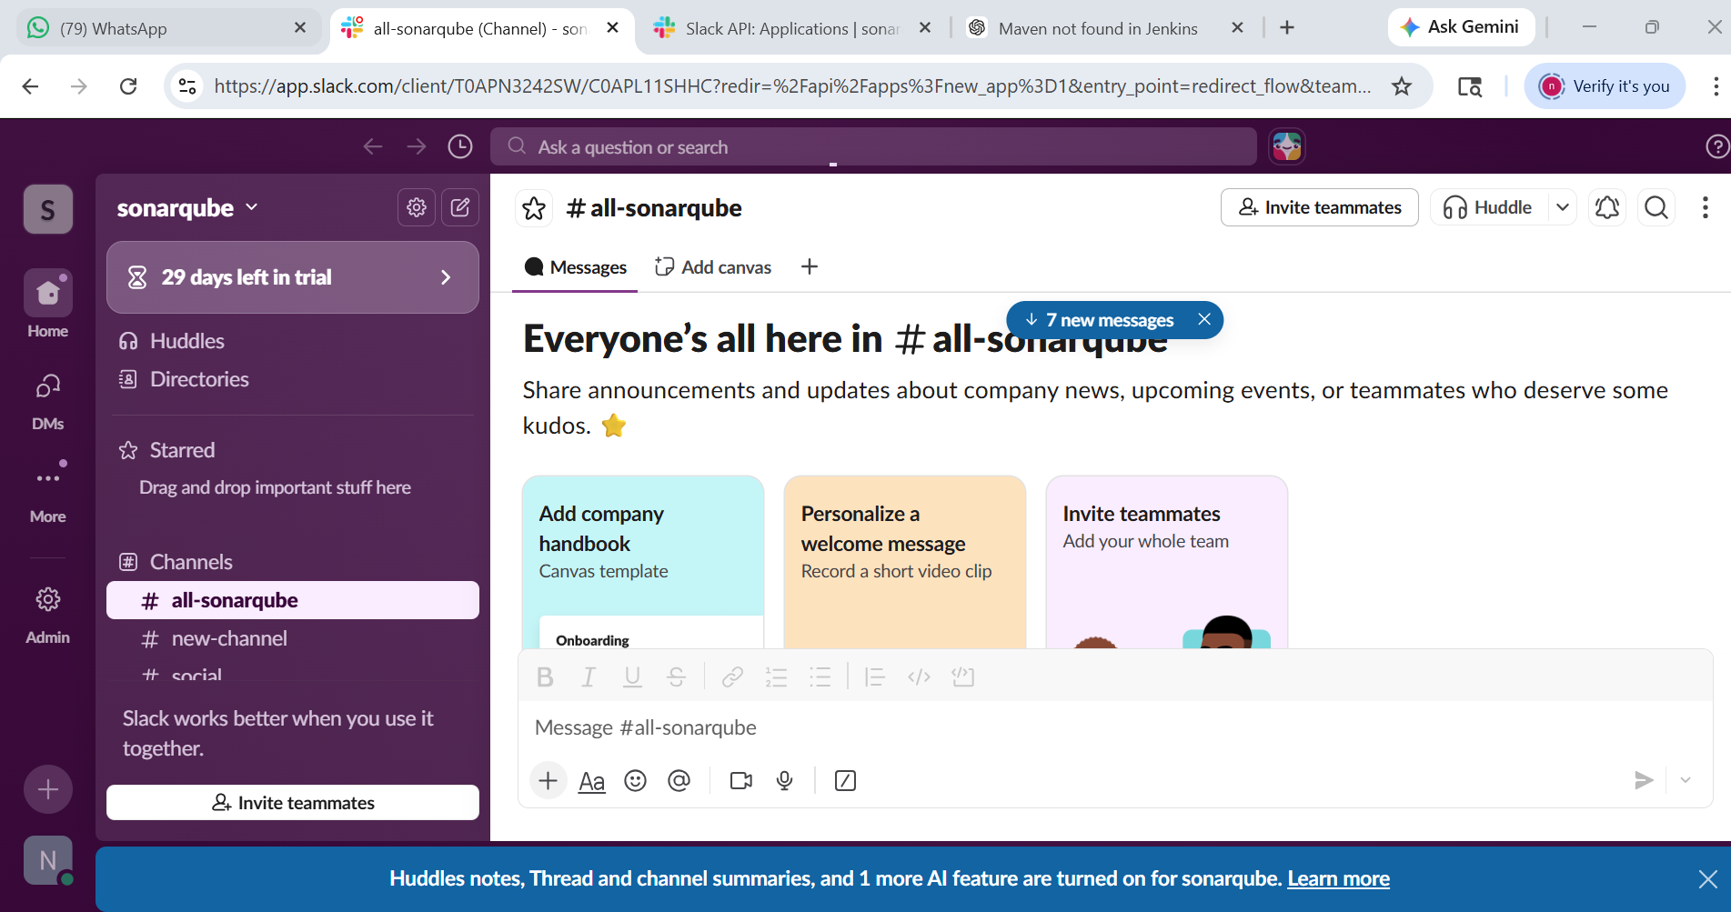

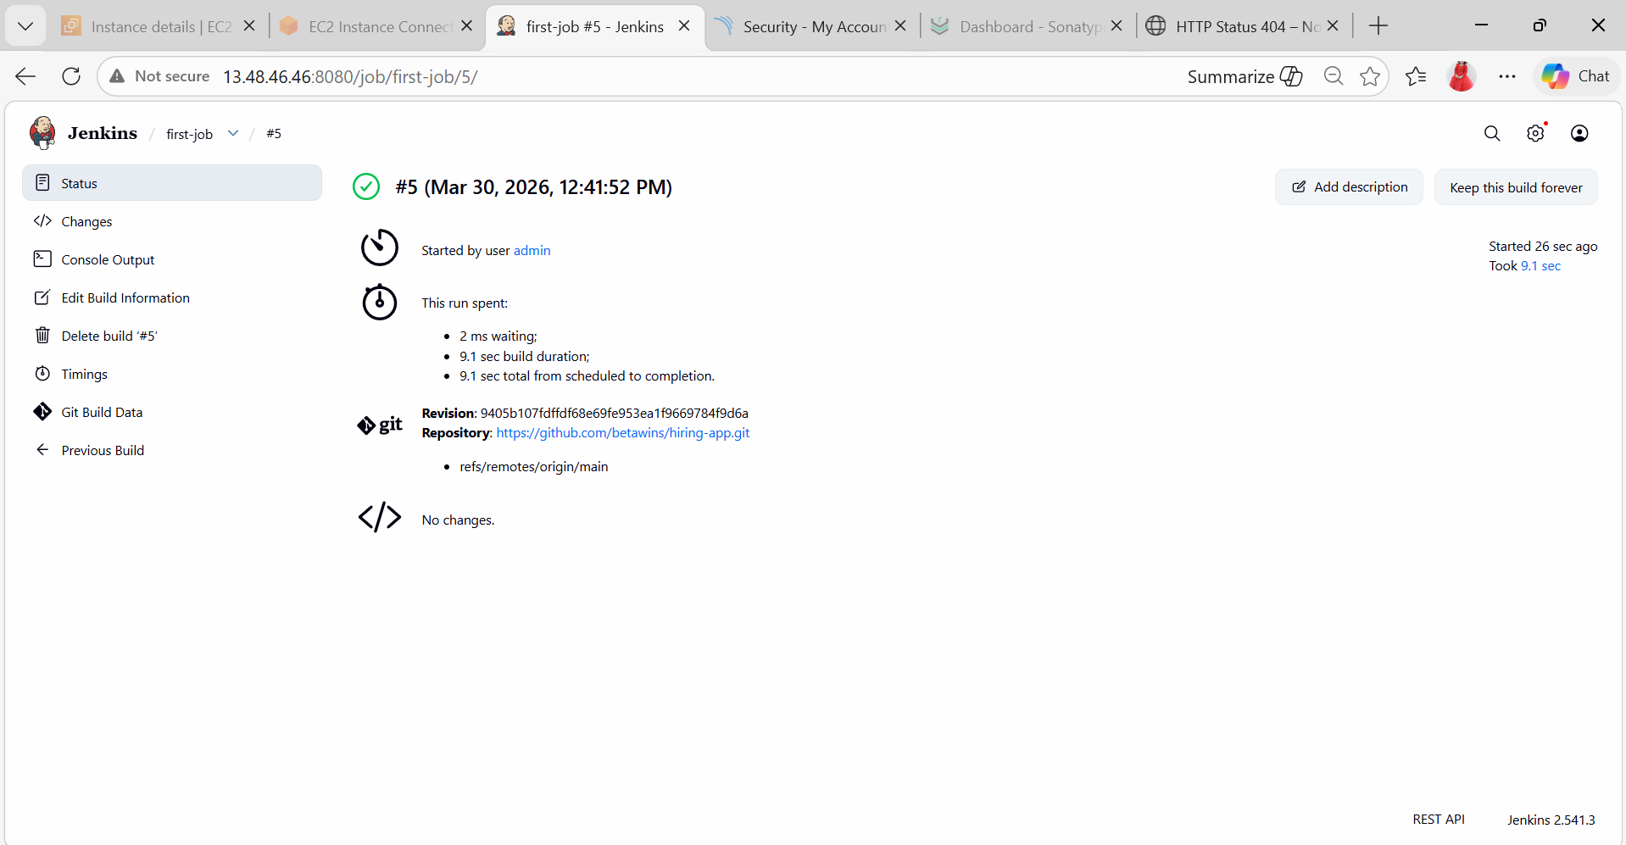

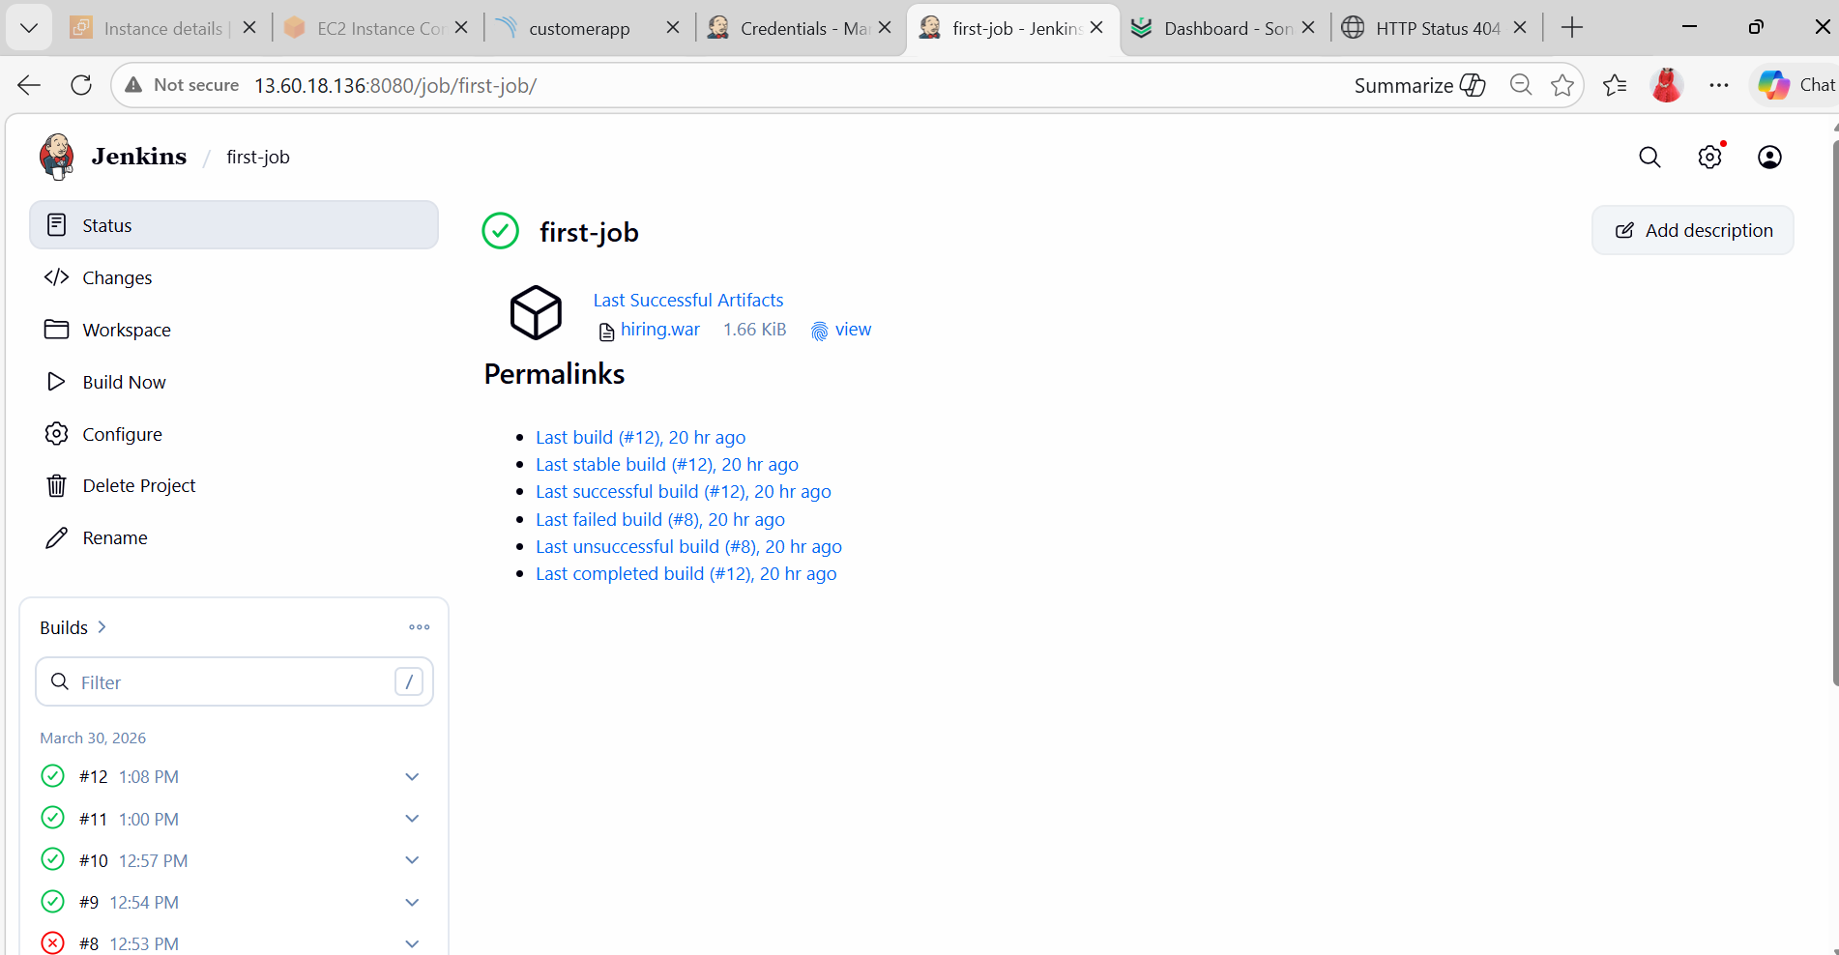
- GLOBAL TOOL CONFIG (AMAZON LINUX)
Manage Jenkins → Global Tool Configuration
Configure JDK
Path (check using readlink -f $(which java)):
/usr/lib/jvm/java-17-openjdk
- Name: JDK17
- Uncheck auto install
- Add path
Configure Maven
/usr/share/maven
- Name: Maven
Configure Sonar Scanner
- Name: SonarScanner
- Install automatically ✔
- SONARQUBE INTEGRATION
Manage Jenkins → Configure System
Add SonarQube Server
- Name: SonarQube
- URL:
http://<EC2-IP>:9000
Add Token
SonarQube:
My Account → Security → Tokens
Jenkins:
Manage Jenkins → Credentials
- Kind: Secret Text
- ID: sonar-token
Connect Token
Select sonar-token in Sonar config
Enable environment variables
PART 2: FREESTYLE JOB
Step 1: Create Job
Freestyle Project
Step 2: Git Clone
https://github.com/betawins/hiring-app.git
Step 3: Build
Maven Build
Click:
Invoke top-level Maven targets
Fill:
- Maven Version: Maven (from Step 10)
- Goals:
clean package
This does:
Compile code
Create .war file

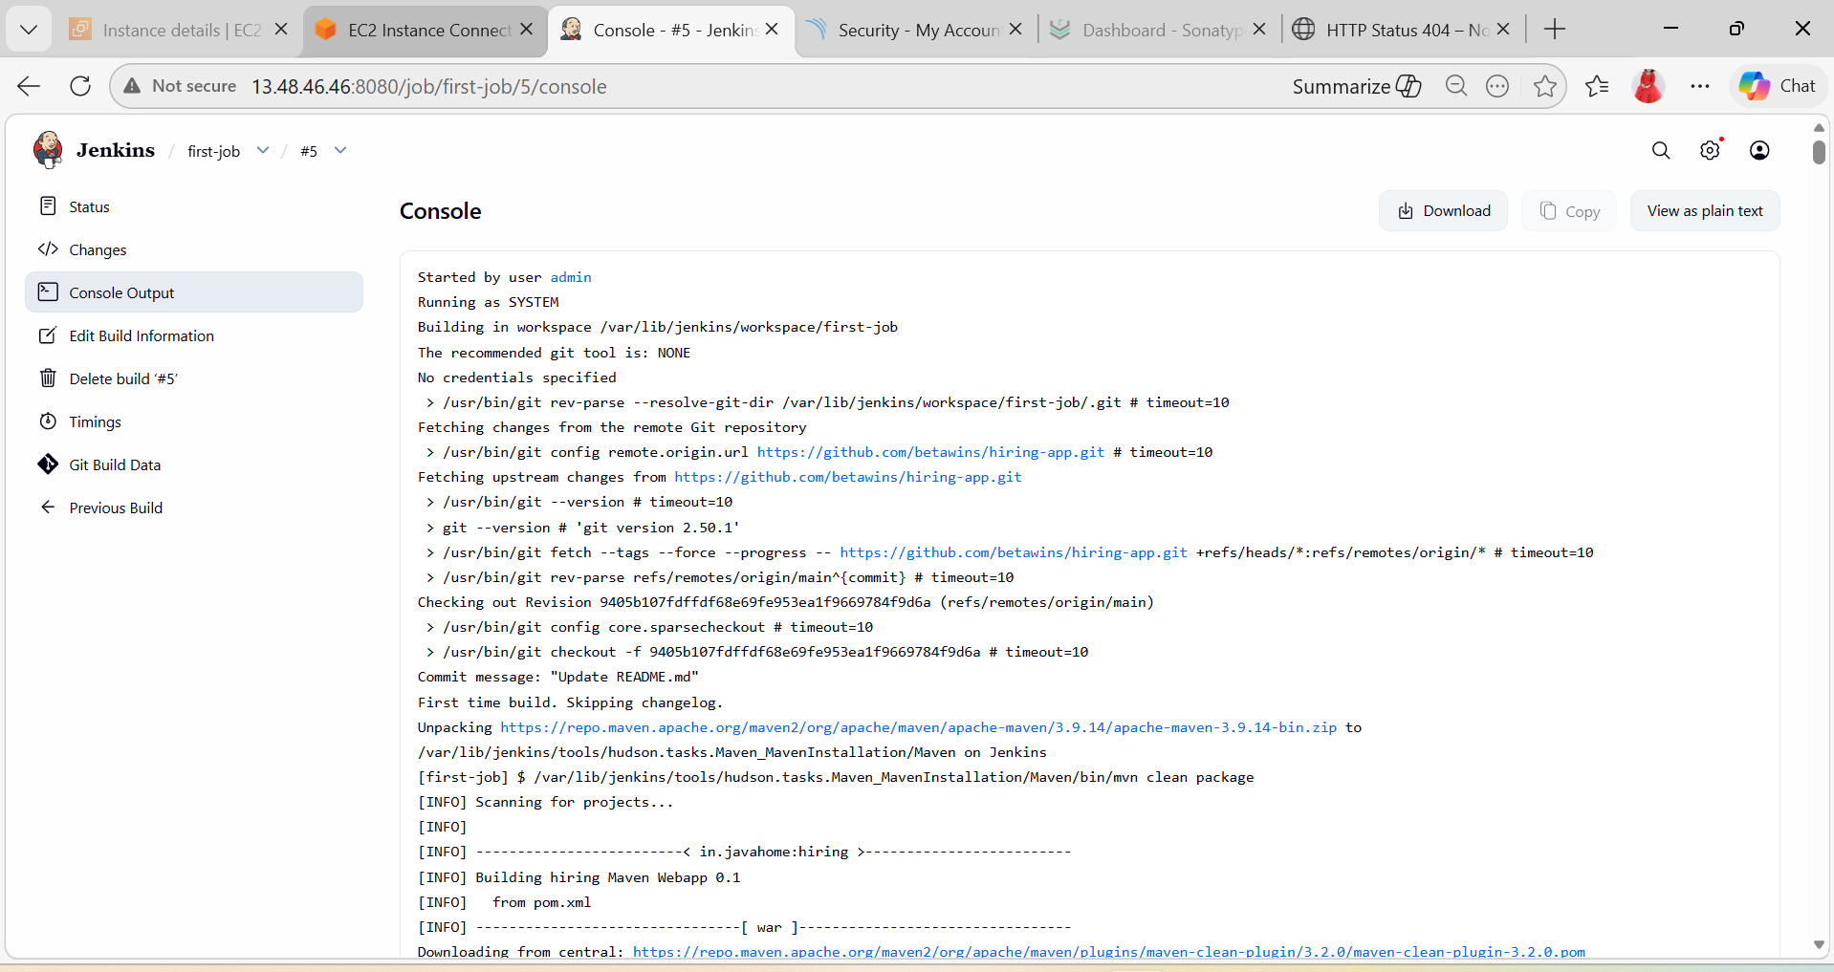

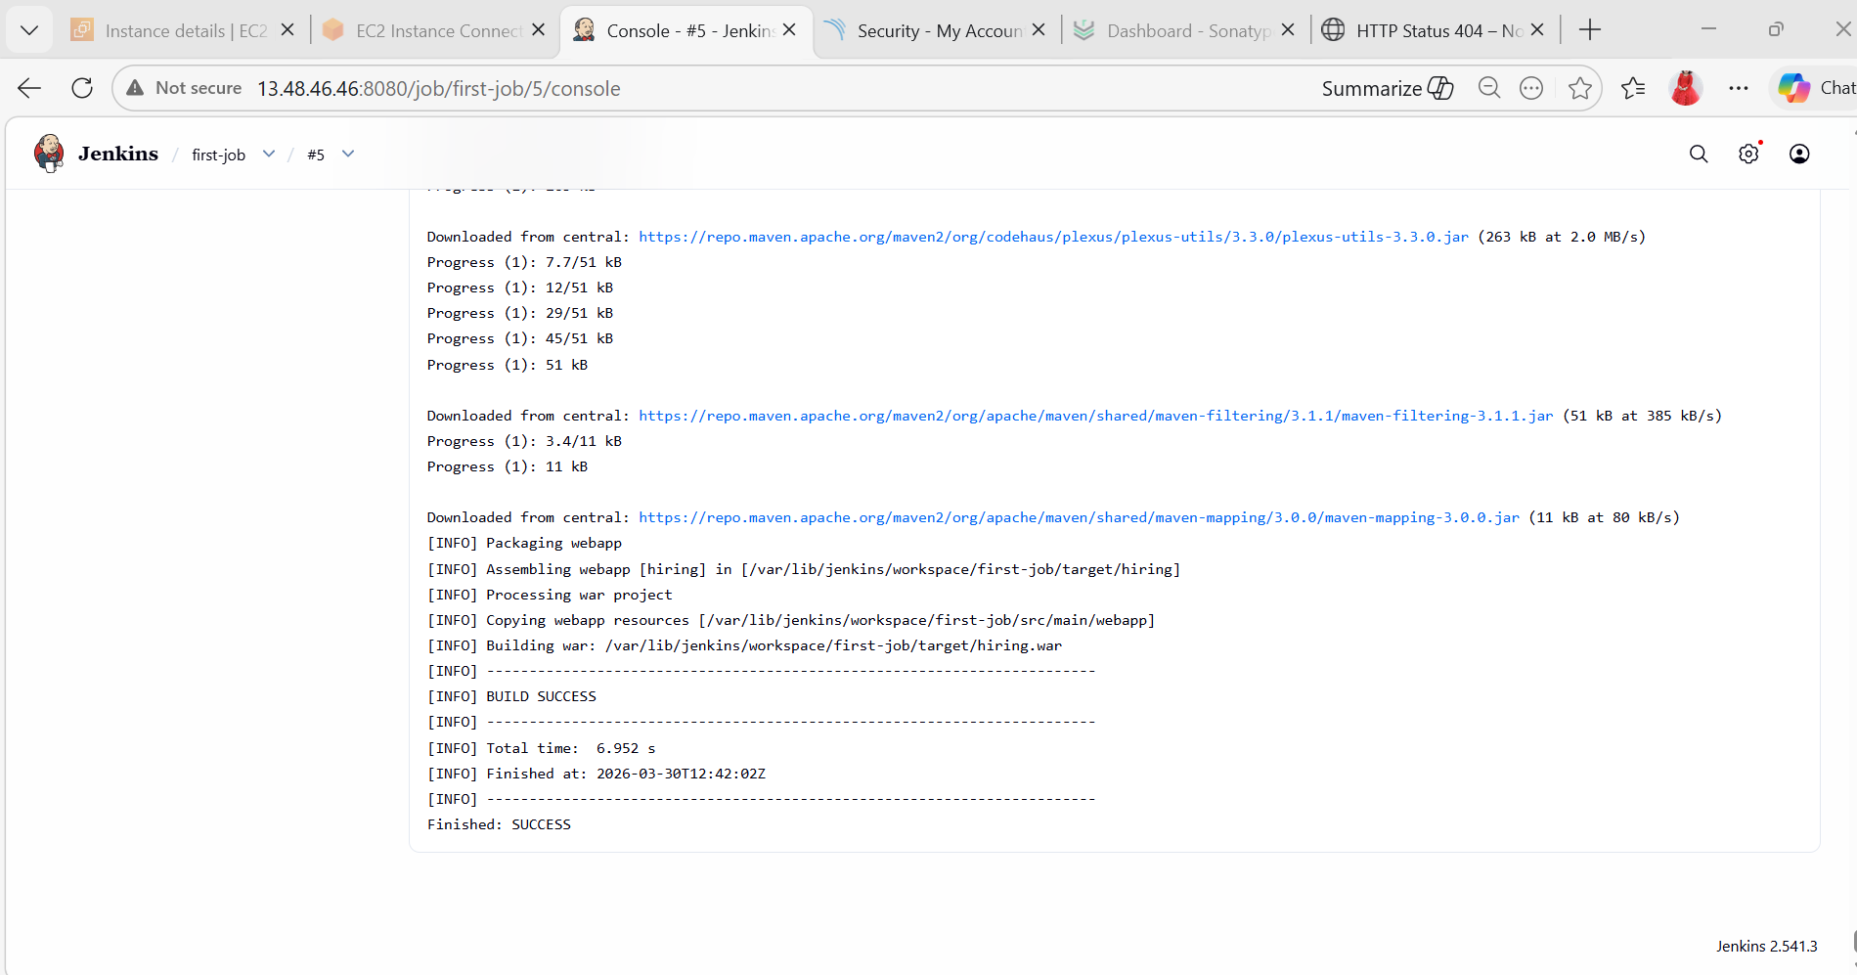
- SonarQube Analysis
Add Execute Shell:
mvn sonar:sonar \
-Dsonar.projectKey=hiring-app \
-Dsonar.host.url=http://<EC2-IP>:9000 \
-Dsonar.login=<TOKEN>

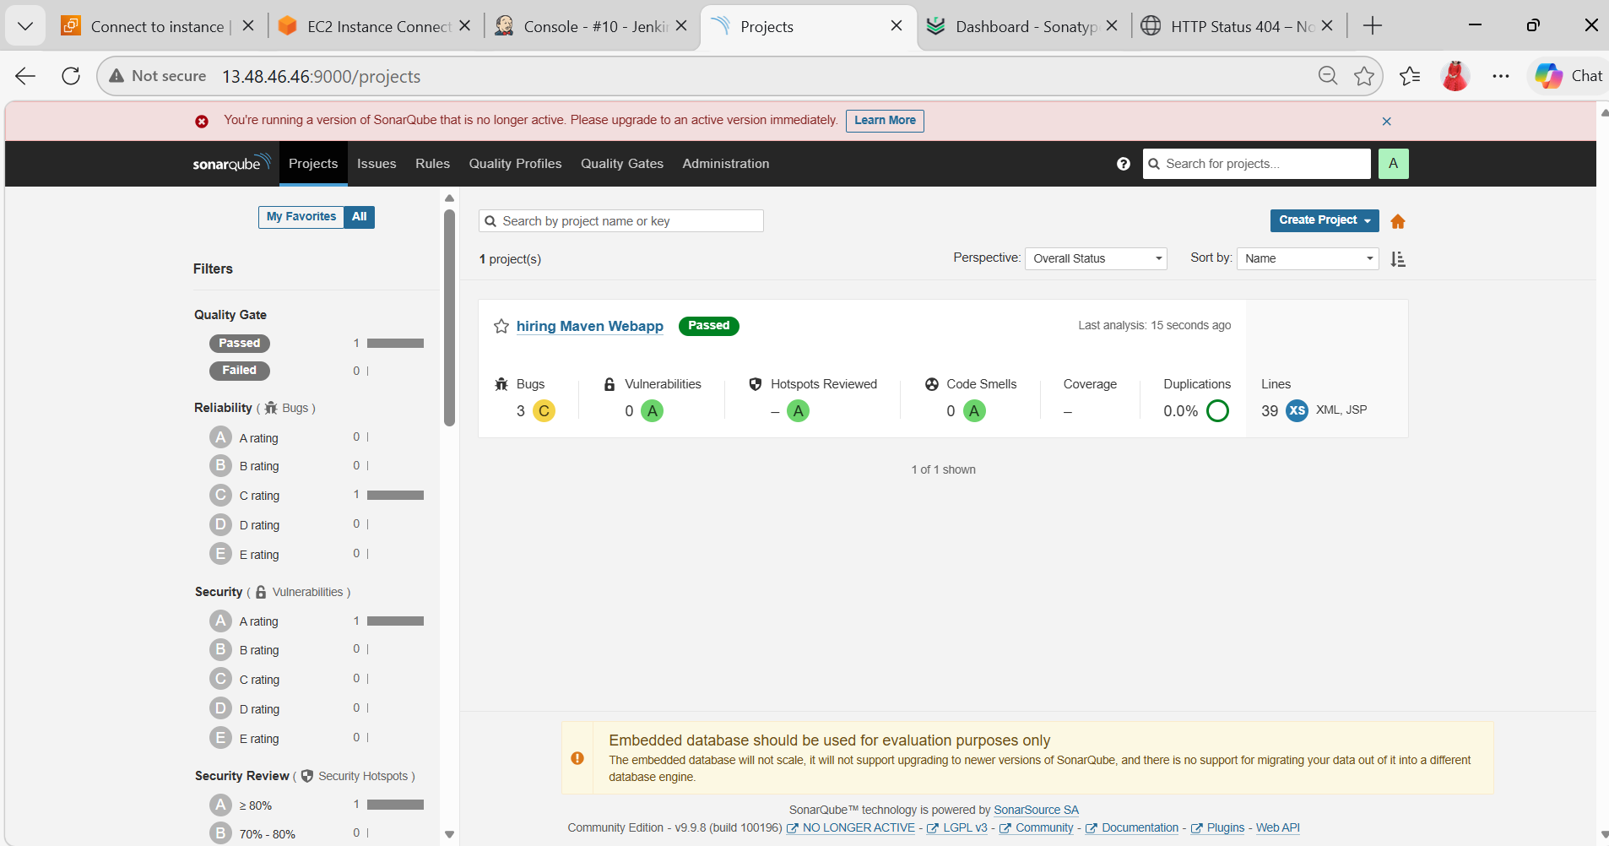

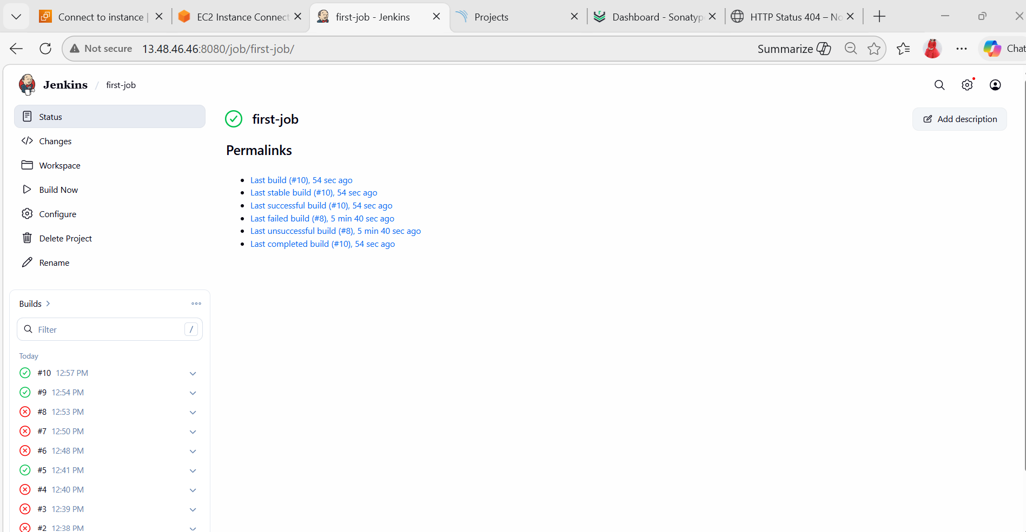

- Upload to Nexus
Add post-build:
- Artifact: target/*.war
Repository: releases
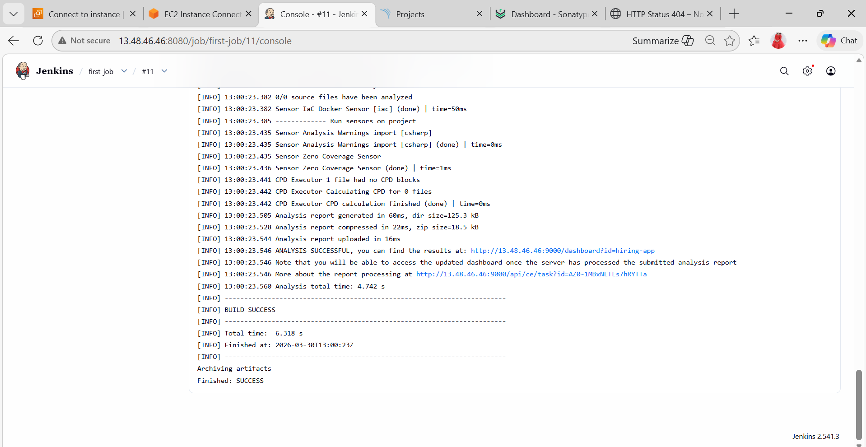
- Deploy On tomcat
Step 6: Deploy to Tomcat
cp target/*.war /opt/tomcat/webapps/
(If Docker Tomcat → use docker cp)
docker cp target/*.war tomcat:/usr/local/tomcat/webapps/
- VERIFY PROJECT LOCATION
Run:
pwd
You are currently:
/home/ec2-user
But your project is NOT here
- GO TO JENKINS WORKSPACE
Jenkins stores code here:
cd /var/lib/jenkins/workspace/
ls
You’ll see your job name:
docker (or your job name)
Go inside:
cd docker
ls
- CHECK TARGET FOLDER
ls target
You should see:
something.war
If NOT → build issue
STEP 4: COPY WAR FILE (CORRECT WAY)
Now run:
docker cp target/*.war tomcat:/usr/local/tomcat/webapps/

NOW FINAL STEP (VERY IMPORTANT)
Open your application
Go to browser:
http://<EC2-IP>:8082
Then try:
http://<EC2-IP>:8082/hiring
Because your file is:
hiring.war
Tomcat automatically deploys it as:
/hiring

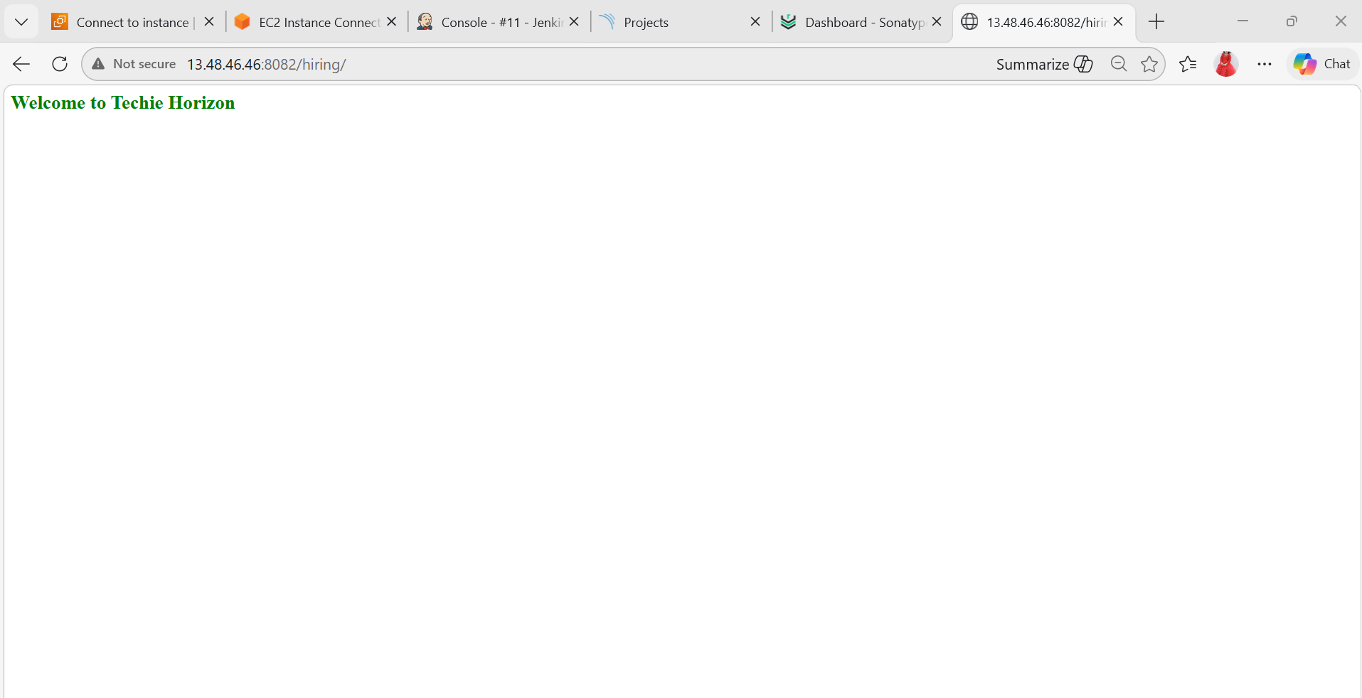

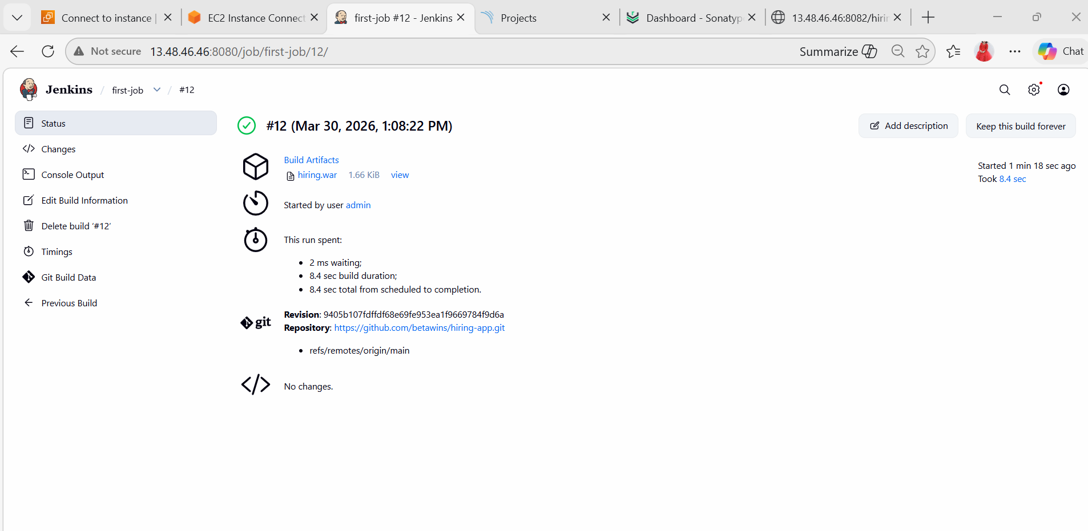
- Slack Notification
Configure Webhook + Channel

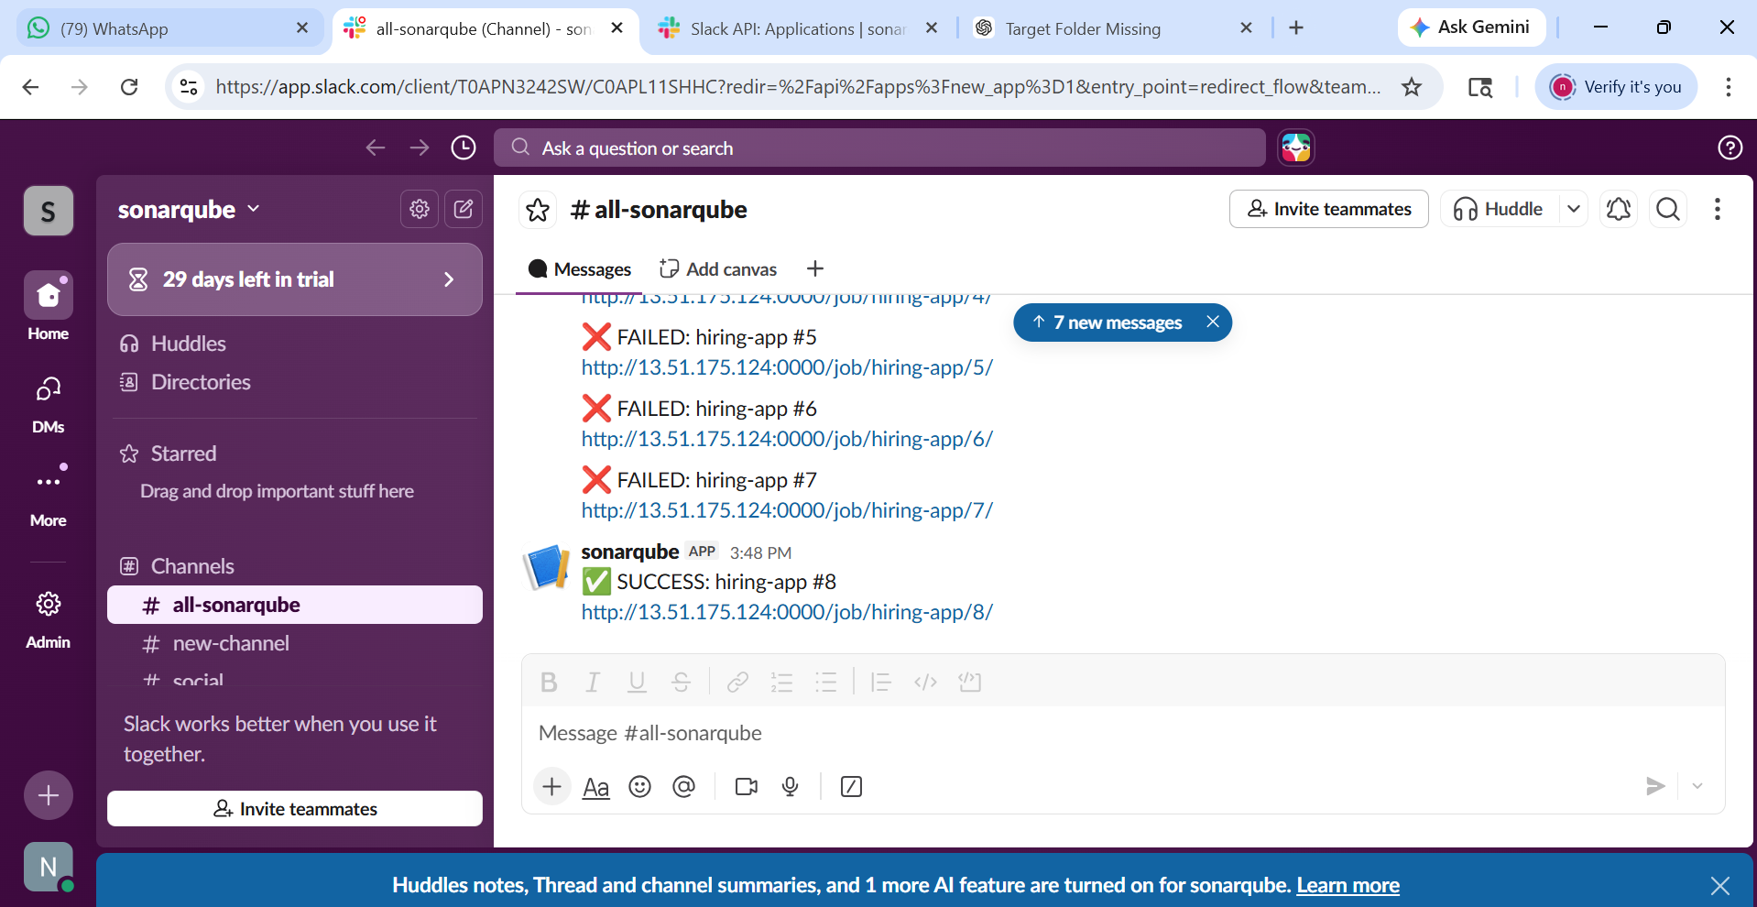

- Setup a Jenkins CICD pipeline using Declarative pipeline using feature-1.1 branch.
Source Code: https://github.com/betawins/sabear_simplecutomerapp/tree/feature-1.1
stages:
- Git Clone
- SonarQube Integration
- Maven Compilation
- Nexus Artifactory
- Slack Notification
- Deploy On tomcat
Create New Job
1. Click New Item
2. Enter name: feature
3. Select Pipeline
4. Click OK
pipeline {
agent any
tools {
maven 'Maven'
}
environment {
SONAR_URL = "http://13.60.18.136:9000"
NEXUS_URL = "http://13.60.18.136:8081"
}
stages {
stage('Git Clone') {
steps {
git branch: 'feature-1.1',
url: 'https://github.com/betawins/sabear_simplecutomerapp.git'
}
}
stage('Build') {
steps {
sh 'mvn clean package'
}
}
stage('SonarQube Analysis') {
steps {
withCredentials([string(credentialsId: 'sonar-token', variable: 'TOKEN')]) {
sh """
mvn sonar:sonar \
-Dsonar.projectKey=customer-app \
-Dsonar.host.url=$SONAR_URL \
-Dsonar.login=$TOKEN
"""
}
}
}
stage('Deploy to Tomcat') {
steps {
sh 'docker cp target/*.war tomcat:/usr/local/tomcat/webapps/'
}
}
}
post {
success {
echo "Pipeline SUCCESS "
}
failure {
echo "Pipeline FAILED "
}
}
}
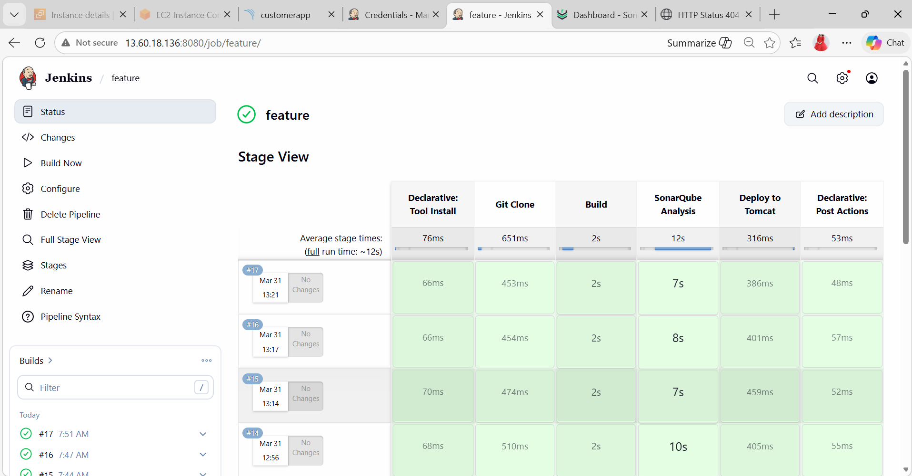

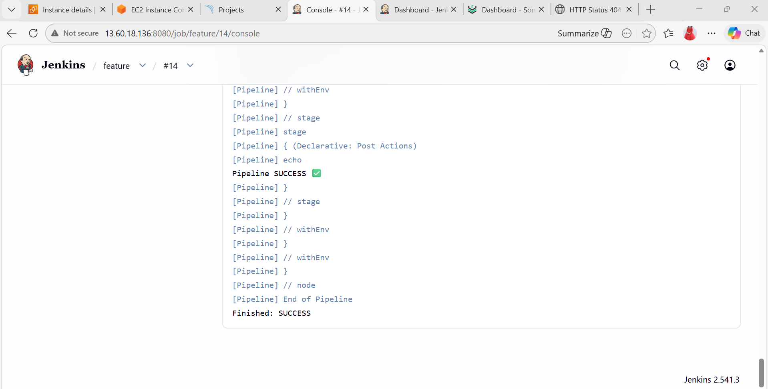

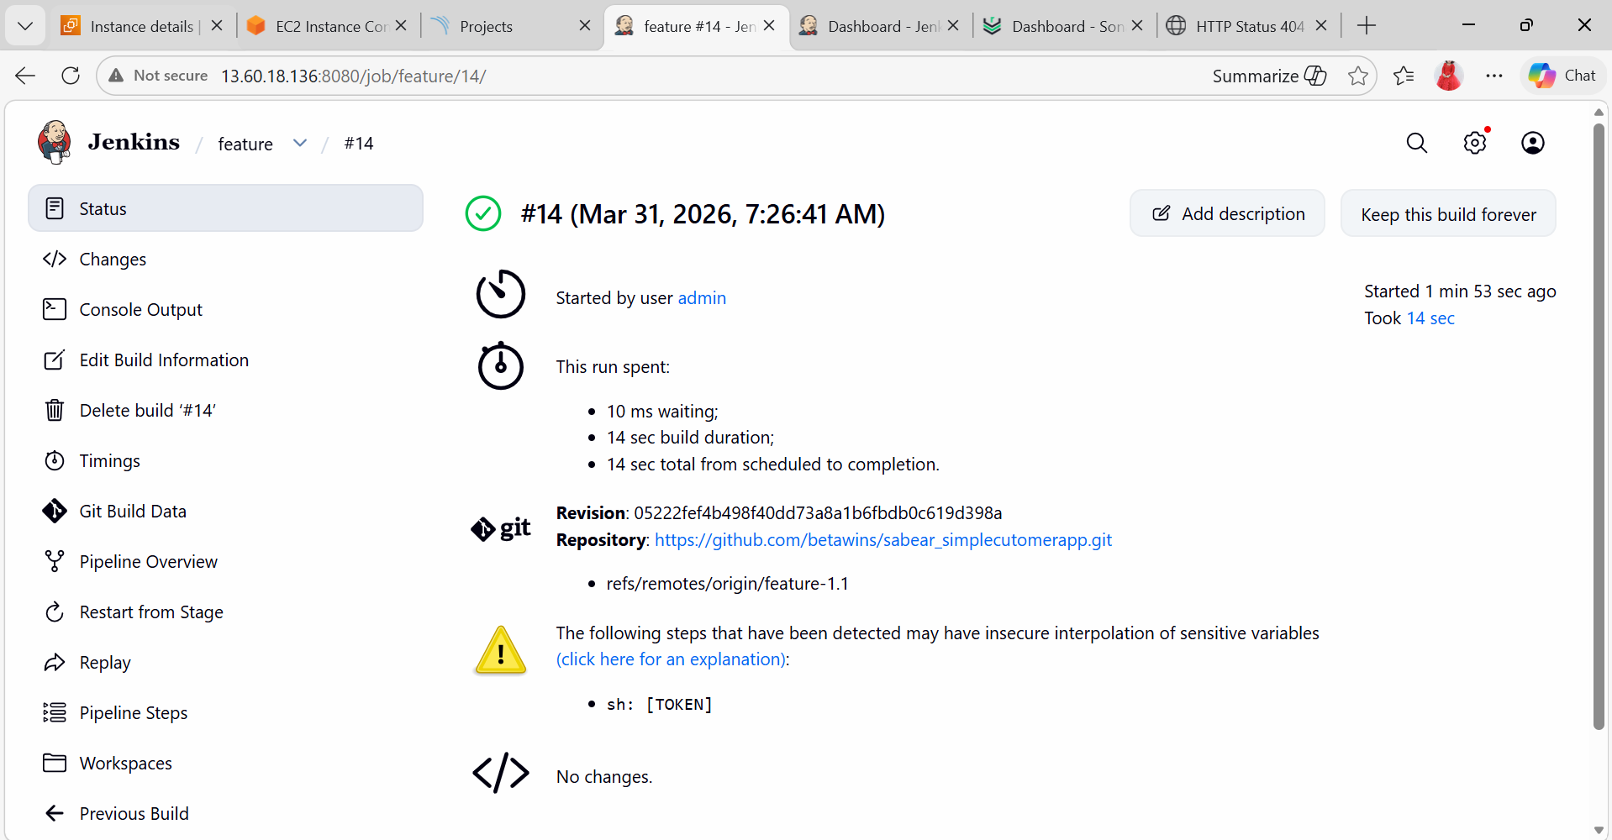
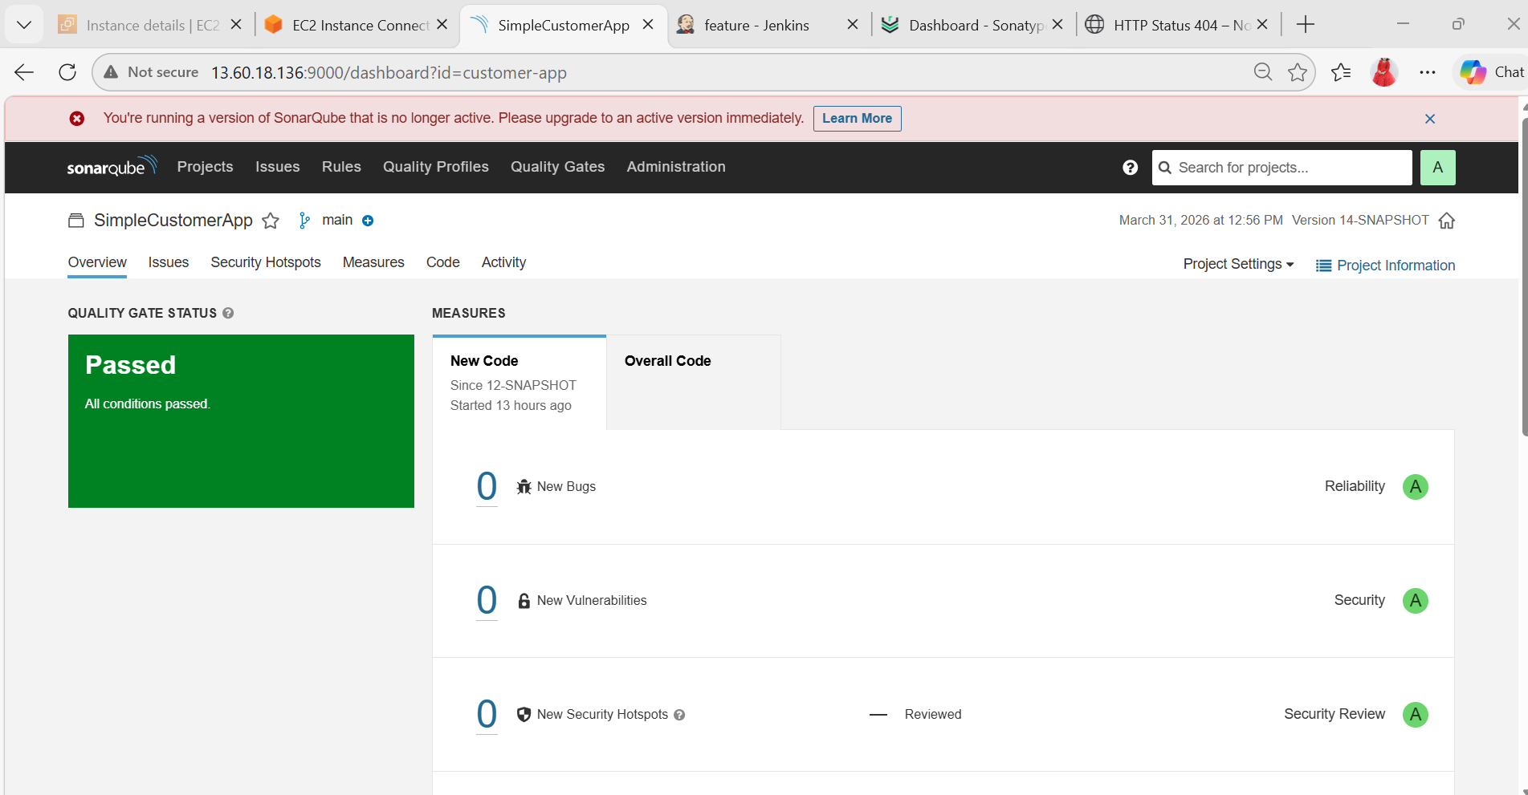

- Setup a Jenkins CICD pipeline using Scripted pipeline using feature-1.1 branch.
Source Code: https://github.com/betawins/sabear_simplecutomerapp/tree/feature-1.1
stages:
- Git Clone
- SonarQube Integration
- Maven Compilation
- Nexus Artifactory
- Slack Notification
- Deploy On tomcat

Create New Job
1. Click New Item
2. Enter name: CI-CD pipeline
3. Select Pipeline
4. Click OK
node {
stage('Clean Workspace') {
deleteDir()
}
stage('Git Clone') {
git branch: 'feature-1.1',
url: 'https://github.com/betawins/sabear_simplecutomerapp.git'
}
stage('SonarQube Analysis') {
withSonarQubeEnv('sonar-toAken') {
sh """
mvn clean verify sonar:sonar \
-Dsonar.projectKey=customerapp \
-Dsonar.projectName=customerapp
"""
}
}

stage('Build Application') {
sh 'mvn clean package'
}
stage('Get WAR File Name') {
script {
def WAR_FILE = sh(
script: "ls target/*.war",
returnStdout: true
).trim()
env.WAR_FILE = WAR_FILE
echo "WAR FILE: ${env.WAR_FILE}"
}
}
stage('Upload to Nexus') {
nexusArtifactUploader(
nexusVersion: 'nexus3',
protocol: 'http',
nexusUrl: '13.60.18.136:8081',
groupId: 'com.example',
version: "${BUILD_NUMBER}",
repository: 'maven-releases',
credentialsId: 'nexus-creds',
artifacts: [
[
artifactId: 'SimpleCustomerApp',
classifier: '',
file: "${env.WAR_FILE}",
type: 'war'
]
]
)
}
stage('Deploy to Tomcat (Docker)') {
sh """
docker exec tomcat rm -rf /usr/local/tomcat/webapps/*.war || true
docker cp ${env.WAR_FILE} tomcat:/usr/local/tomcat/webapps/
"""
}
stage('Slack Notification') {
slackSend(
channel: '#devops',
message: "✅ CI/CD SUCCESS - Build ${BUILD_NUMBER}"
)
}
}
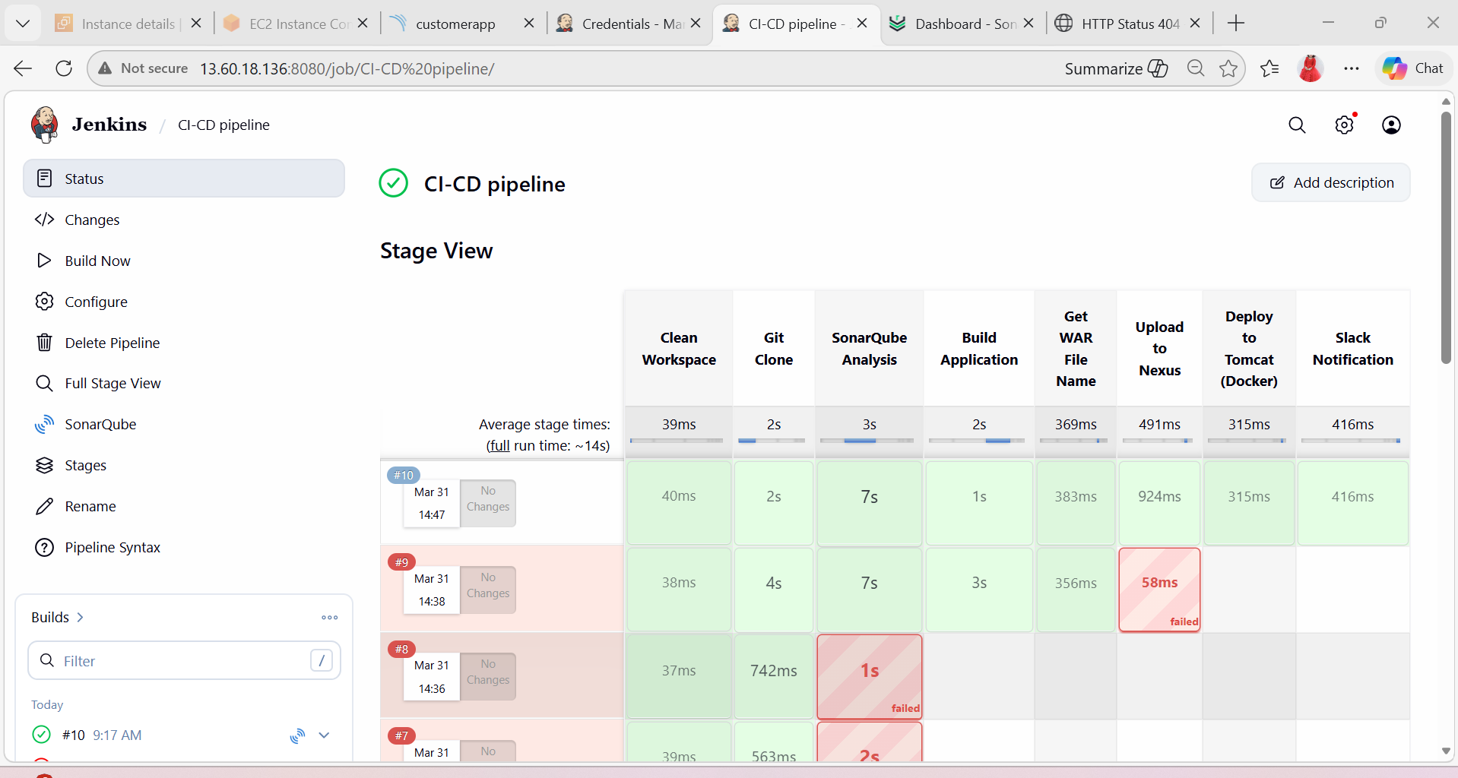
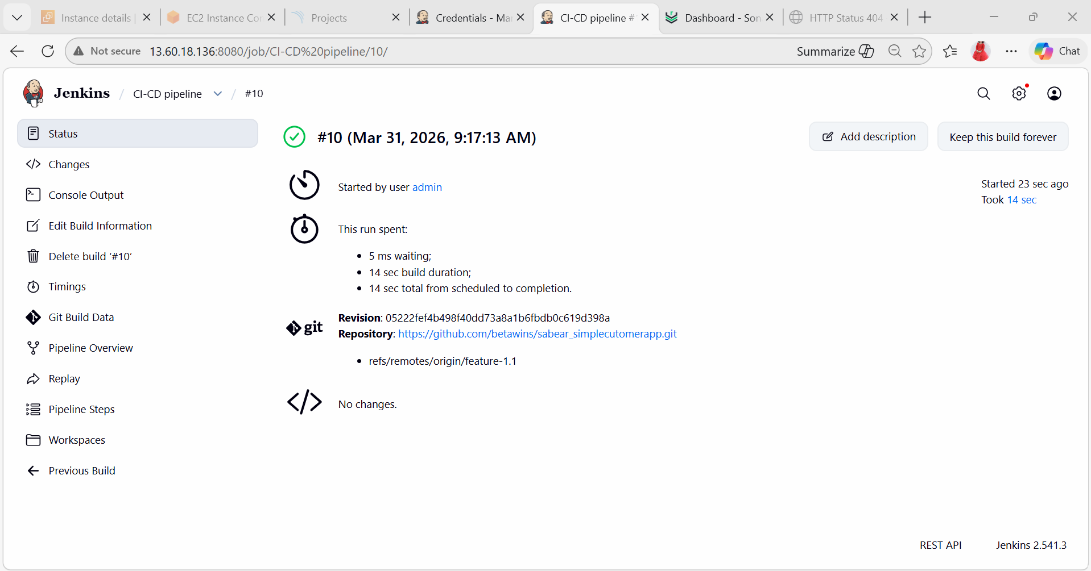

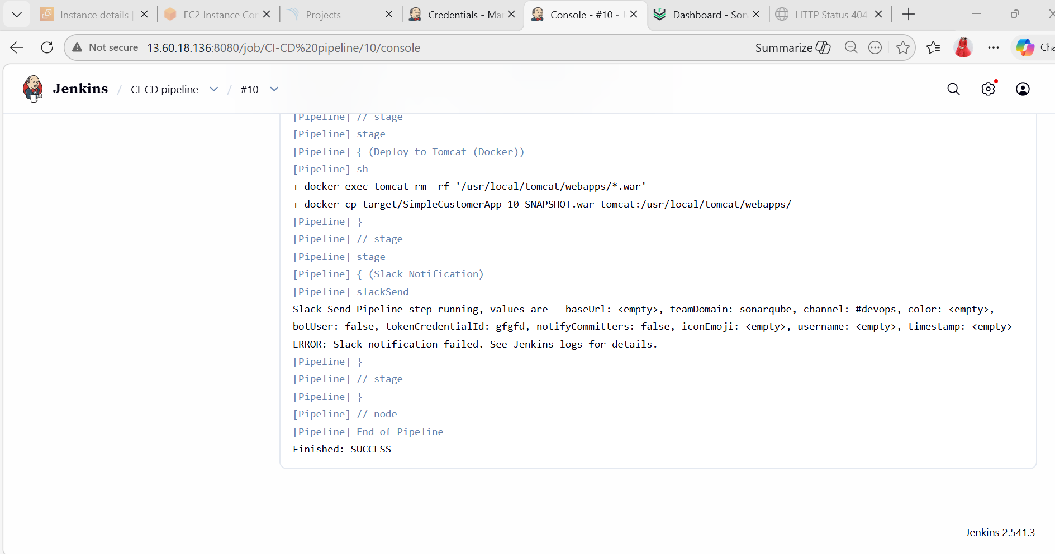

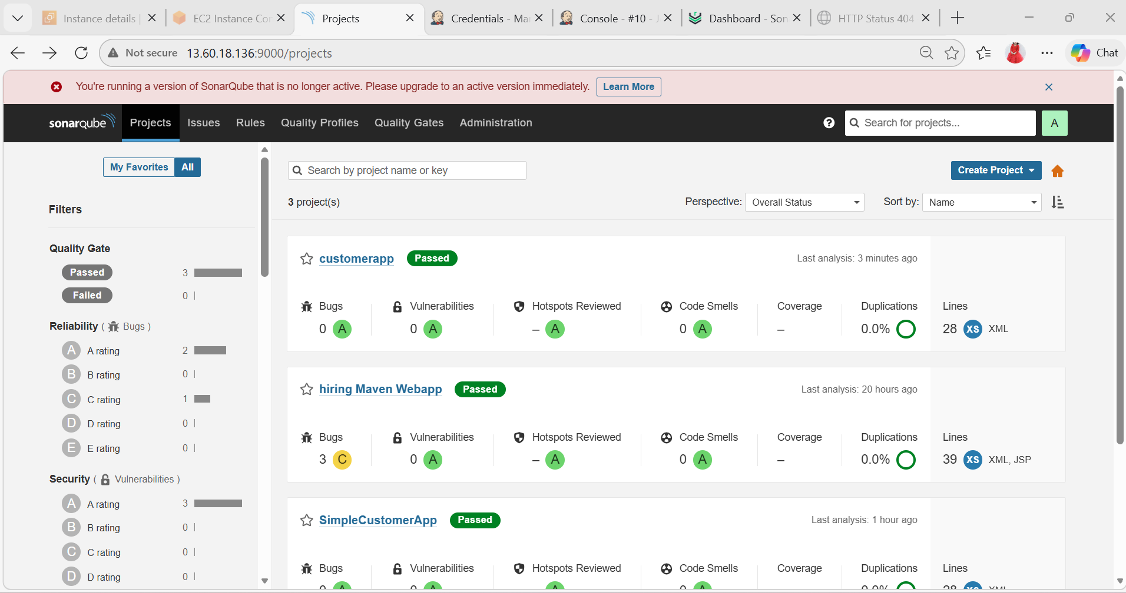

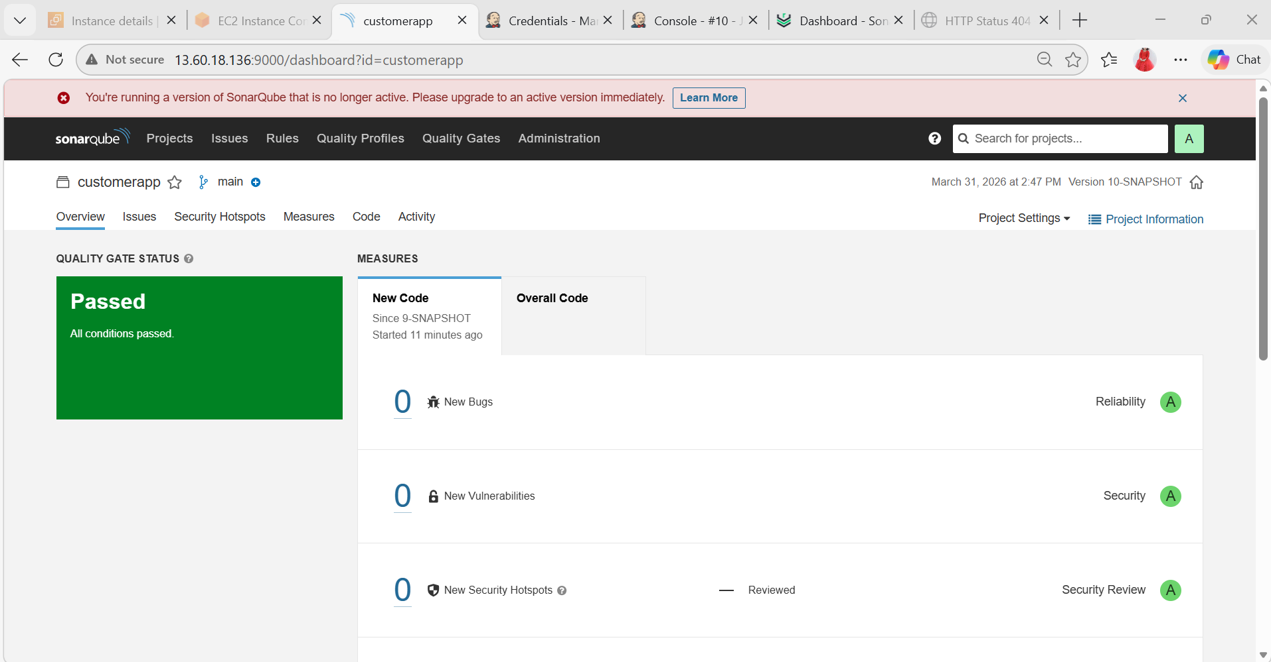
- Write sample skeleton of pipelines.
Create New Job
1. Click New Item
2. Enter name: sample-skeleton
3. Select Pipeline
4. Click OK
pipeline {
agent any

stages {
stage('Build') {
steps {
echo 'Hello World'
}
}
}
}
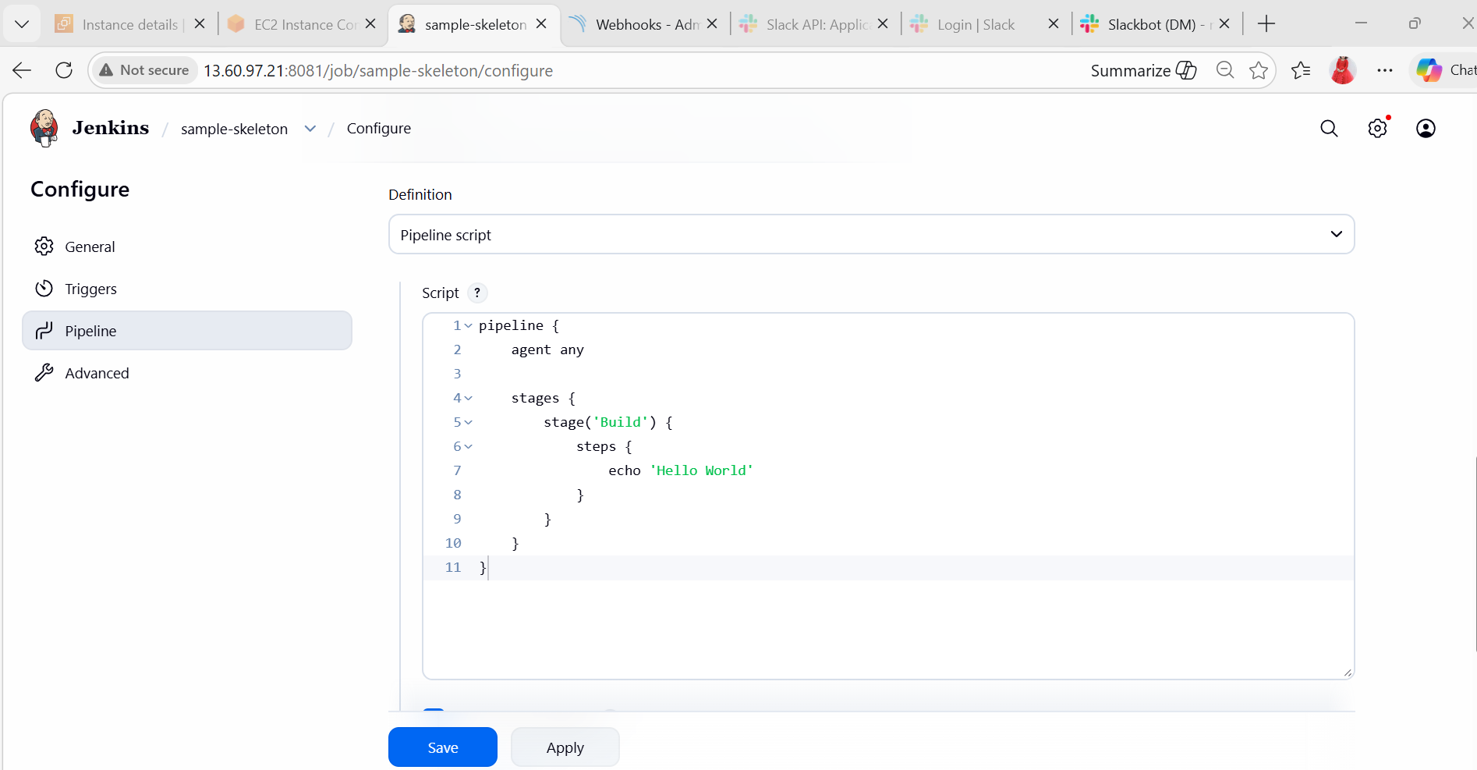
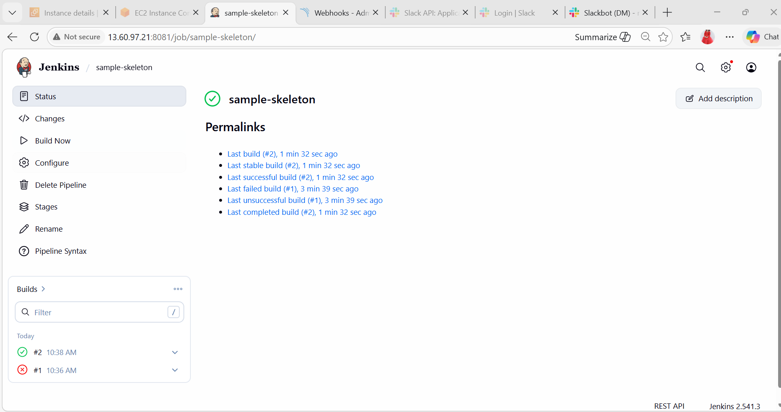
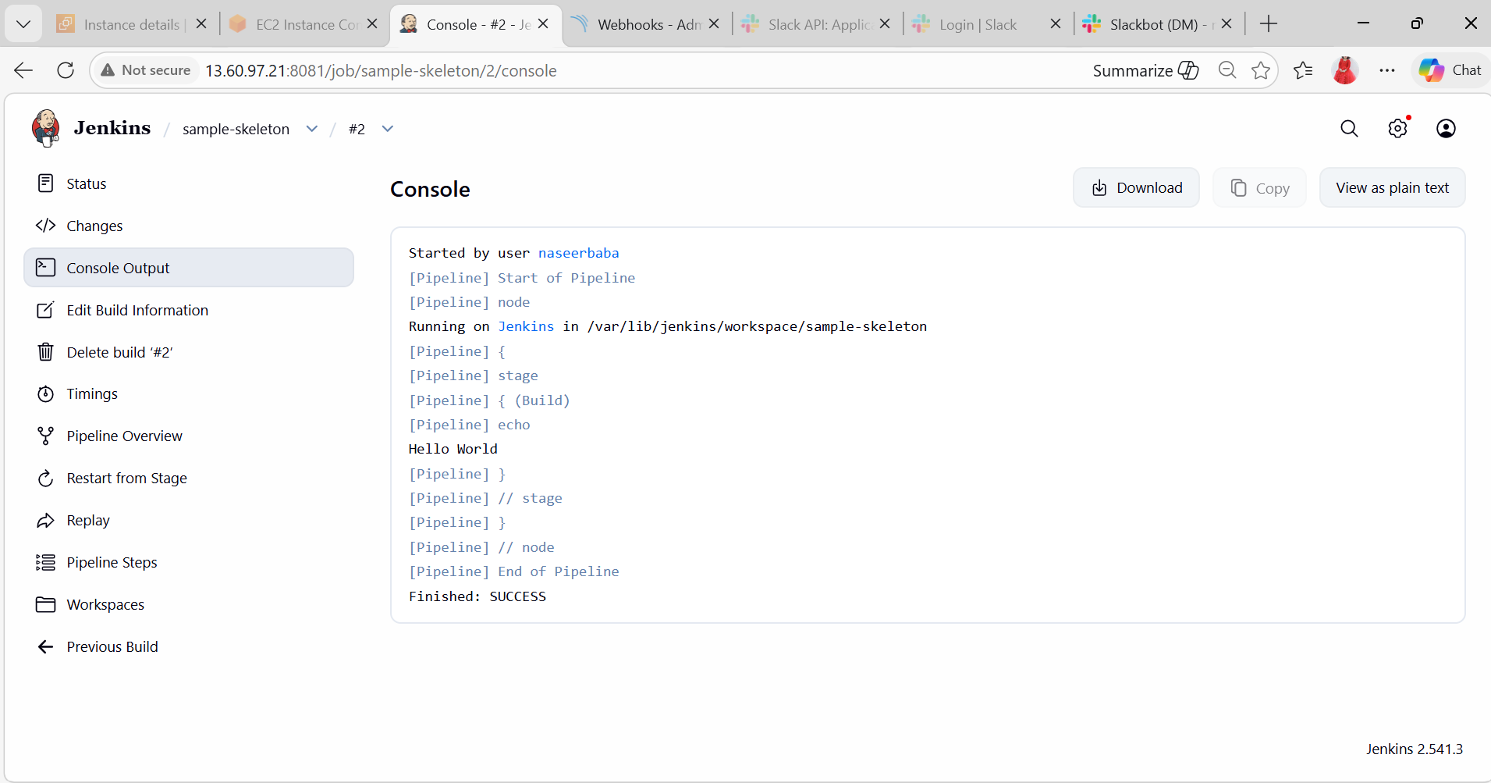

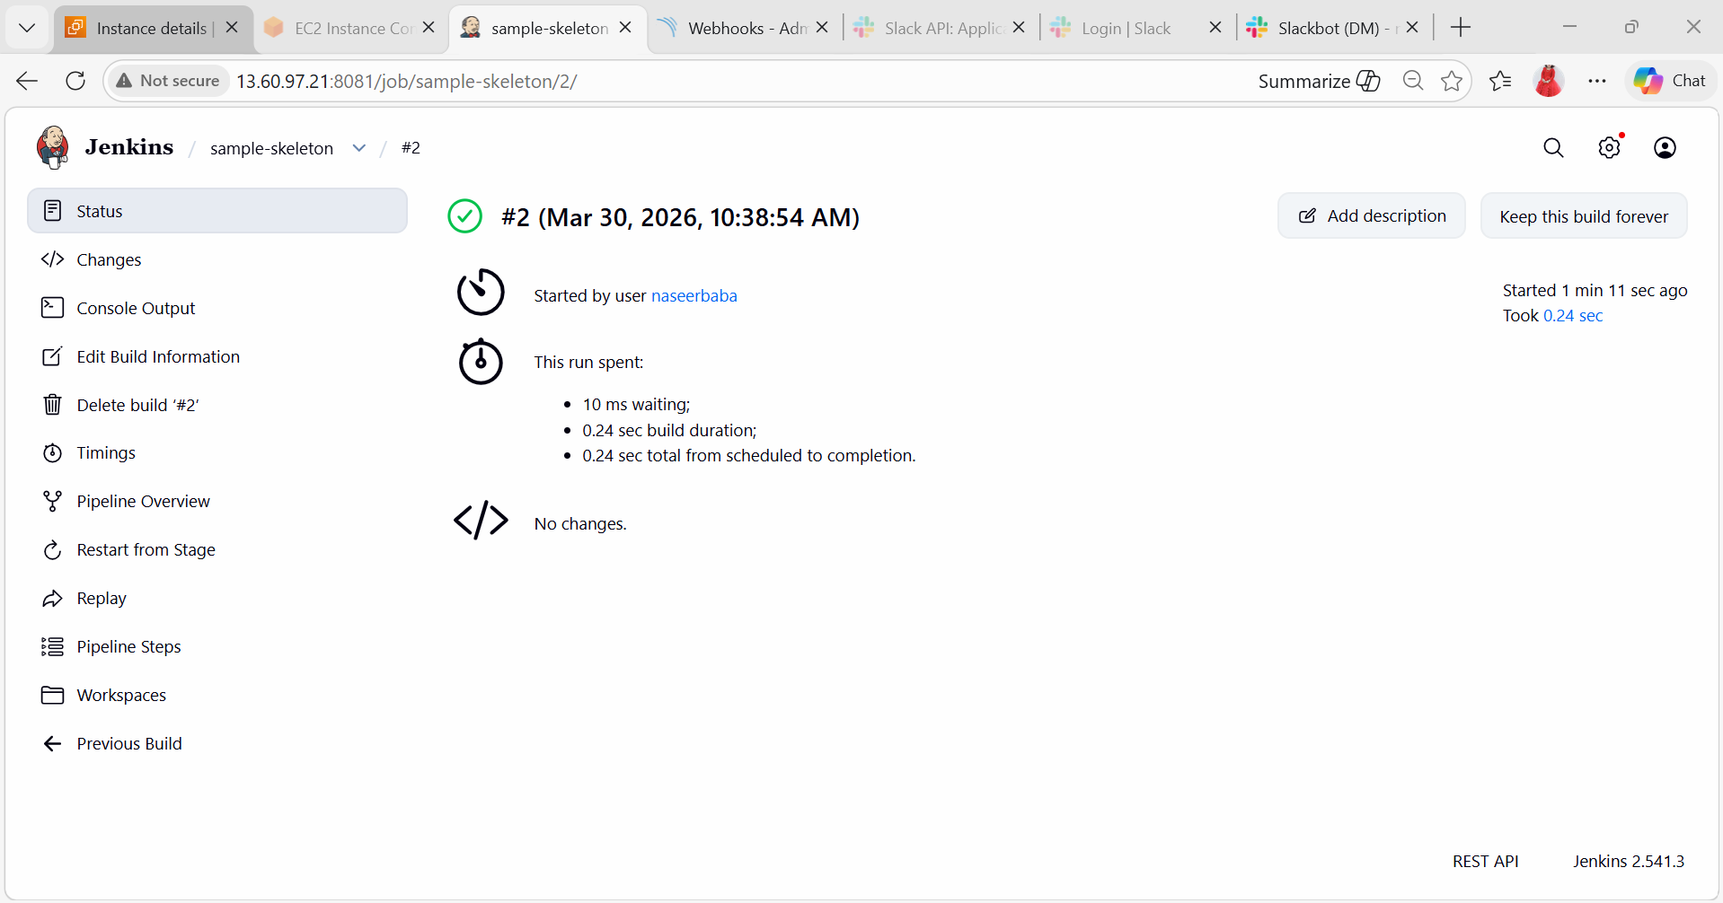
5) Create a parameterized job in Jenkins.
Source Code: https://github.com/betawins/spring3-mvc-maven-xml-hello-world-1.git
- Launch EC2 (Amazon Linux)
- Go to AWS → EC2 → Launch Instance
- Launch and connect:
- Install Java (Jenkins requirement)
sudo yum update -y
sudo yum install java-17-amazon-corretto -y
Check:
java -version
- Install Jenkins
sudo wget -O /etc/yum.repos.d/jenkins.repo \
https://pkg.jenkins.io/redhat-stable/jenkins.repo
sudo rpm --import https://pkg.jenkins.io/redhat-stable/jenkins.io-2023.key
sudo yum install jenkins -y
- Start Jenkins
sudo systemctl enable jenkins
sudo systemctl start jenkins
Check status:
sudo systemctl status Jenkins
- Get Jenkins Admin Password
sudo cat /var/lib/jenkins/secrets/initialAdminPassword
Copy this password
- Open Jenkins UI
In browser:
http://<EC2-PUBLIC-IP>:8080
- Paste password
- Click Install Suggested Plugins
- Create admin user
- Install Required Tools
Install Git
sudo yum install git -y
Install Maven
sudo yum install maven -y
Check: mvn -version
- Configure Tools in Jenkins
Go to:
Manage Jenkins → Global Tool Configuration
Add:
- JDK → Name: java17
- Maven → Name: maven3
Save
- Create Parameterized Job
- Jenkins Dashboard → New Item
- Name: Parameterized-Build
- Select: Freestyle Project
- Click OK
- Enable Parameters
Tick This project is parameterized
Add parameters:
String Parameter
- Name: BRANCH
- Default: main
Choice Parameter
- Name: ENV
- Choices: dev test prod
String Parameter
- Name: MESSAGE
- Default: Hello Jenkins
- Configure Git Repository
In Source Code Management → Git
Repository:
https://github.com/betawins/spring3-mvc-maven-xml-hello-world-1.git
Branch:
${BRANCH}
- Add Build Logic Using Parameters
Add Execute Shell step:
echo "===== FIXING JAVA VERSION ====="
sed -i 's/<jdk.version>1.6<\/jdk.version>/<jdk.version>1.8<\/jdk.version>/g' pom.xml
echo "===== ADDING NEW WAR PLUGIN ====="
# Remove old war plugin
sed -i '/maven-war-plugin/,/<\/plugin>/d' pom.xml
# Add new war plugin
sed -i '/<\/plugins>/i \
<plugin>\
<groupId>org.apache.maven.plugins</groupId>\
<artifactId>maven-war-plugin</artifactId>\
<version>3.3.2</version>\
</plugin>' pom.xml
echo "===== VERIFY ====="
grep -i war-plugin pom.xml
- Build Step (Maven)
In Build → Add build step → Invoke top-level Maven targets
Goals:
clean package
- Save Job
Click Save
- Build with Parameters
- Click Build with Parameters
- Enter:
  - BRANCH = main
  - ENV = dev/test/prod
  - MESSAGE = anything
- Click Build
- Go to:
Build → Console Output
- You should see:
- Selected Environment: dev
Custom Message: Hello Jenkins
Deploying to DEV environment
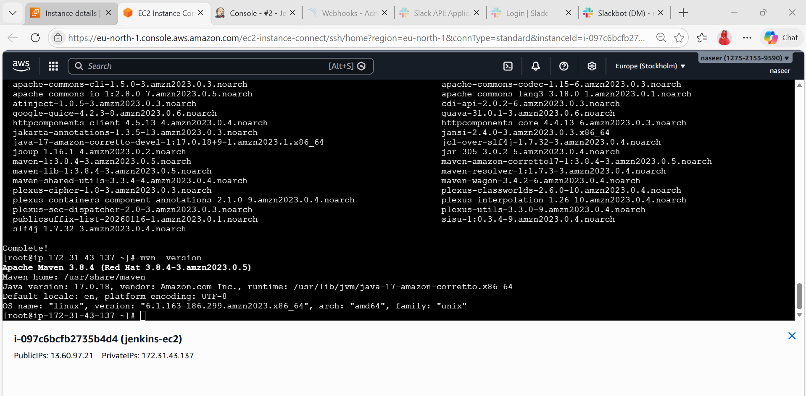

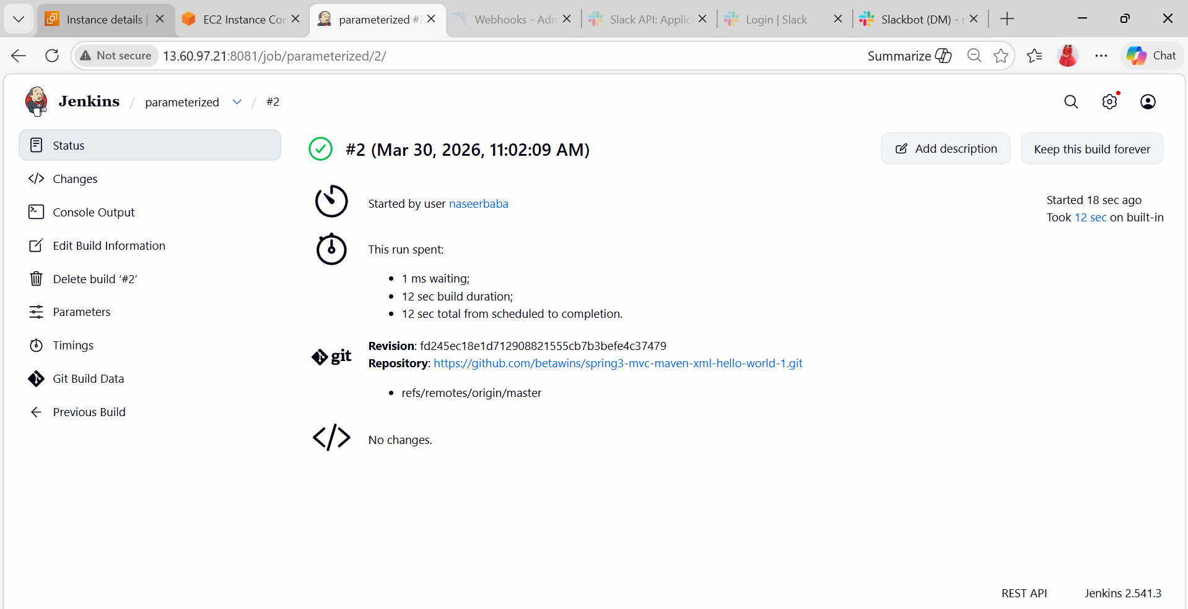
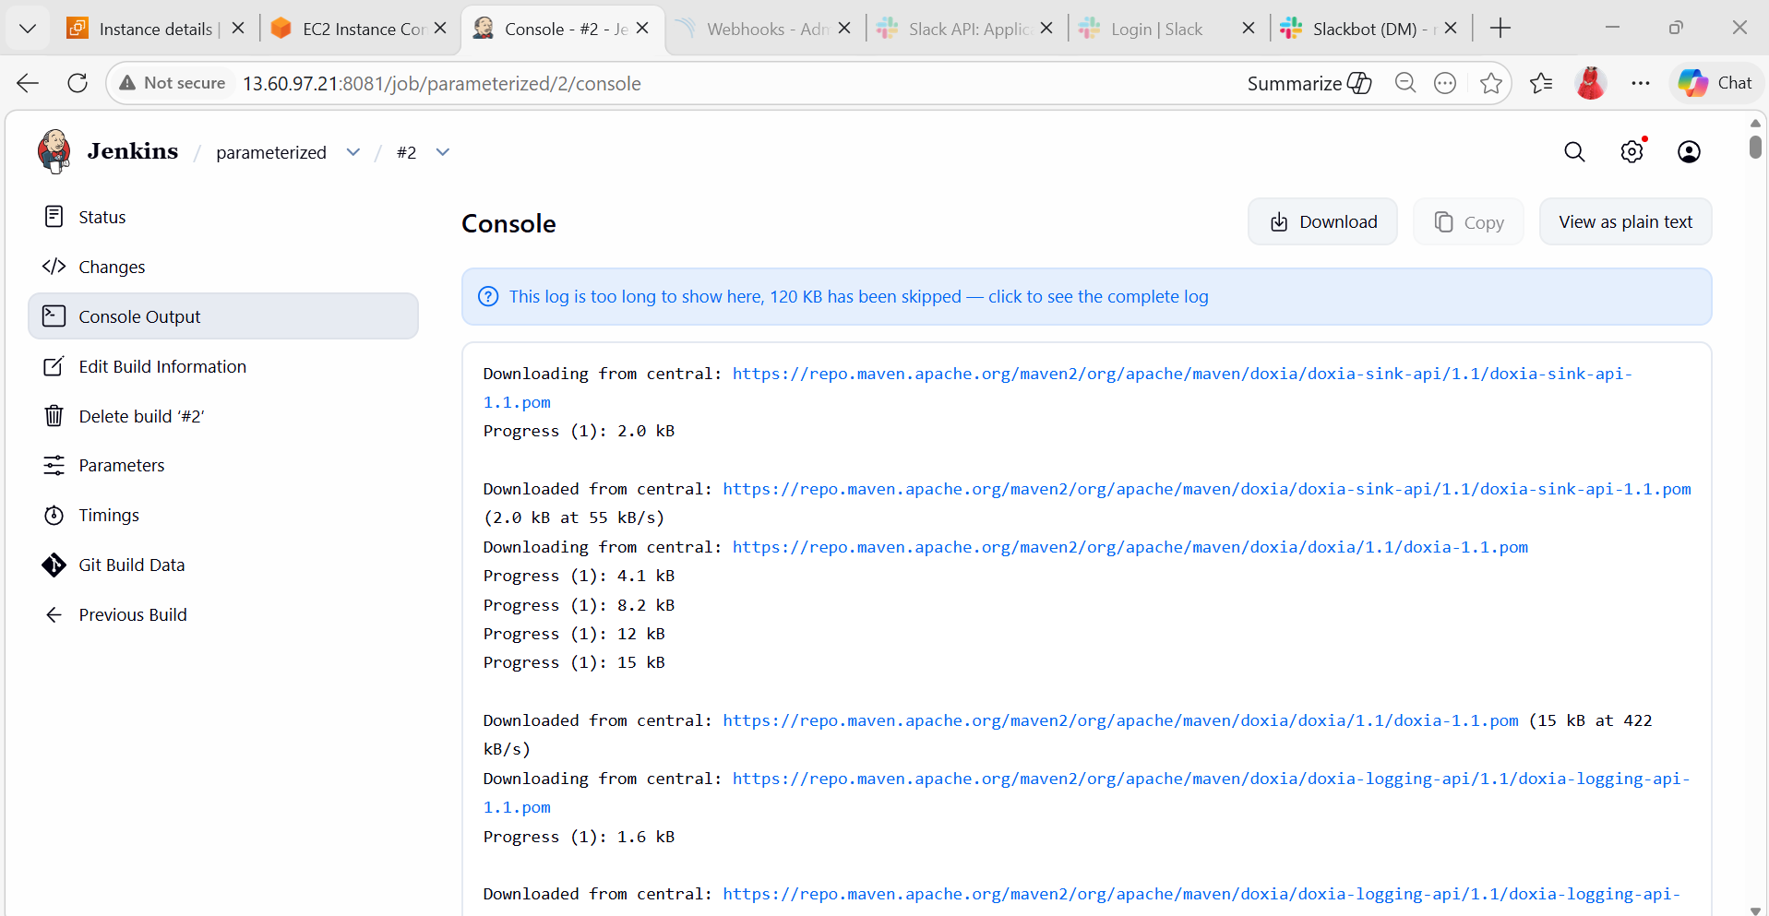

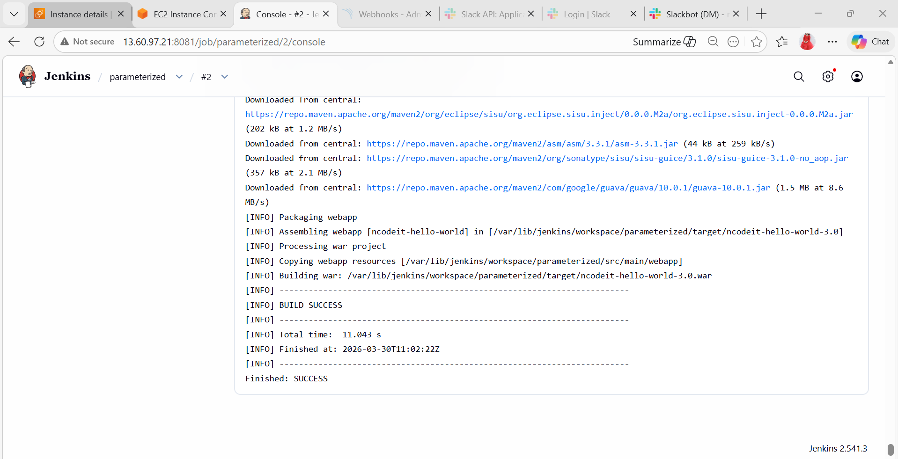
6) Setup one slave machine for Jenkins.
We’ll do this in 4 steps:
- Launch EC2 instances
- Install Java & setup SSH
- Configure Jenkins Master
- Connect Slave (Agent)

step 1: Launch EC2 Instances
Create 2 EC2 instances:
- Master (Jenkins installed)
- Slave (Agent machine)
step 2: Install Java on BOTH machines
SSH into both instances
ssh -i your-key.pem ec2-user@<public-ip>
Install Java (Jenkins requires Java)
sudo yum update -y
sudo amazon-linux-extras enable corretto8
sudo yum install java-1.8.0-amazon-corretto -y
Verify:
java -version
step 3: Setup SSH between Master → Slave
This is VERY IMPORTANT (most people make mistakes here)
- Copy public key content
cat ~/.ssh/id_rsa.pub
Copy the full output.
- Login to Slave EC2
ssh -i your-key.pem ec2-user@44.220.164.227
- Add key manually
mkdir -p ~/.ssh
nano ~/.ssh/authorized_keys
Paste the copied key.
Save:
CTRL + X → Y → Enter
- Set permissions
chmod 700 ~/.ssh
chmod 600 ~/.ssh/authorized_keys
- Test SSH (IMPORTANT)
From Master EC2:
ssh ec2-user@44.220.164.227
If it logs in WITHOUT asking password → SUCCESS
Should connect without password
step 4: Install Jenkins on Master
sudo yum install git -y
sudo wget -O /etc/yum.repos.d/jenkins.repo \
https://pkg.jenkins.io/redhat-stable/jenkins.repo
sudo rpm --import https://pkg.jenkins.io/redhat-stable/jenkins.io.key
sudo yum install jenkins -y
Start Jenkins
sudo systemctl start jenkins
sudo systemctl enable jenkins
Open Jenkins UI:
http://<master-public-ip>:8080
Get initial password:
sudo cat /var/lib/jenkins/secrets/initialAdminPassword
- Add Slave (Agent) in Jenkins
Go to Jenkins Dashboard
Manage Jenkins → Manage Nodes → New Node
Configure Node
Fill details:
- Name: slave-node
- Type: Permanent Agent
Configure settings
Field | Value
Remote root directory | /home/ec2-user
Labels | linux
Usage | Use this node as much as possible
Launch method | Launch agents via SSH
Add Credentials
Click Add → Jenkins
- Kind: SSH Username with private key
- Username: ec2-user
- Private Key:
Paste content of:
cat ~/.ssh/id_rsa
Add Host
- Host: Private IP of Slave
- Credentials: Select created one
Save
Jenkins will connect automatically
FINAL VERIFICATION
Go to: Manage Nodes → slave-node
Status should be: Connected

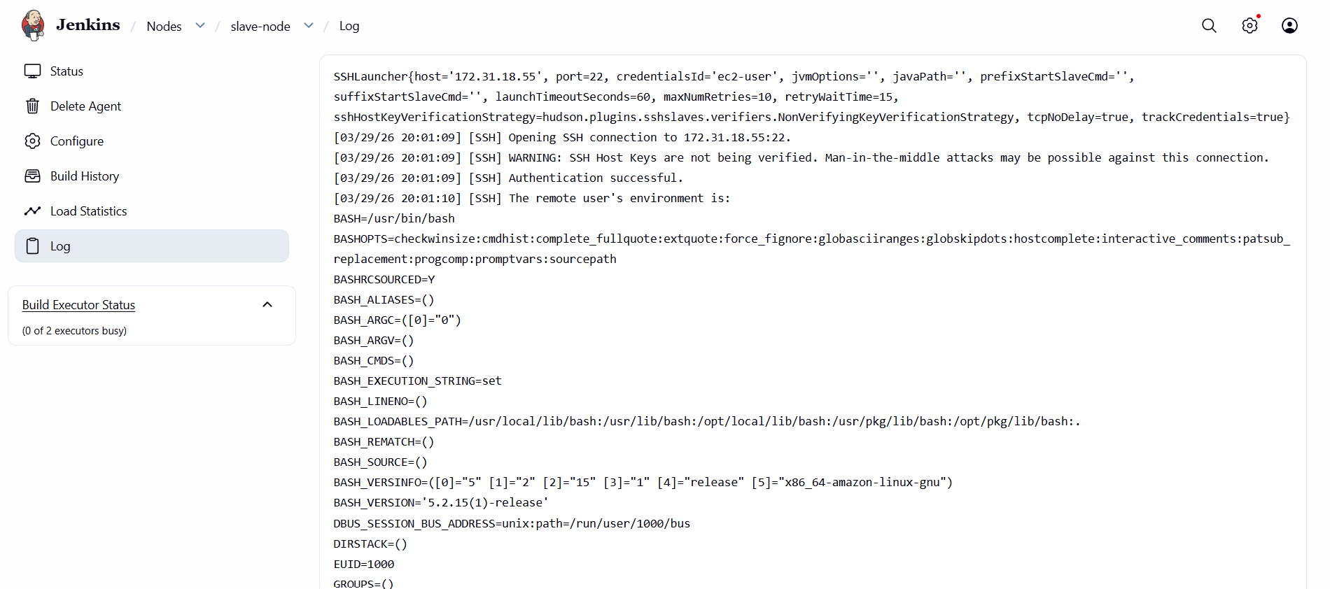
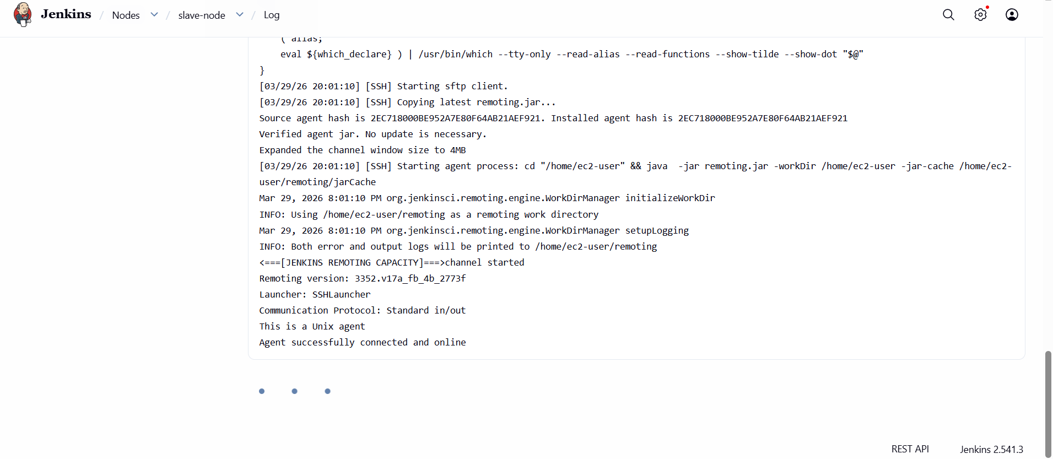

TEST JOB
Create a job:
echo "Hello from Slave"
hostname
